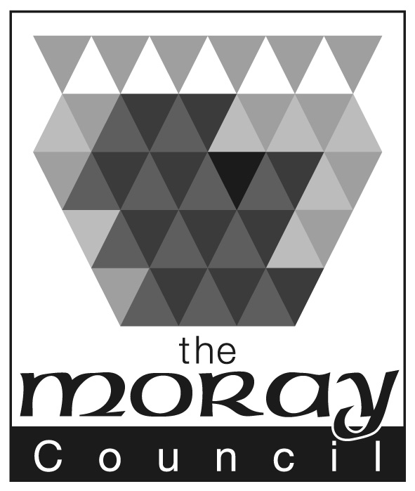

Appendix 5

COMMUNITY SERVICES

Kinship Care
Rose Cottage, Greyfriars Street, Elgin, Moray. IV30 1LF
Contact Kinship Care Senior Social Worker
Telephone: 01343 563686
Fax: 01343 563579
Susan Maclaren | E-mail: ruth.jeffries@moray.gov.uk
Head of Children & Families  and Criminal Justice Services | Website: www.moray.gov.uk
Our Ref: RJ/
Your Ref:

date

Dear

RE: name and address

Kinship Care Assessment

As you may know, (name of applicants) are being assessed by the Moray Council to be kinship carers. They have given your name as a referee who would be able to comment on their home life and abilities with children.

I would be grateful if you could complete the attached personal reference form and return it to me. I may need to talk with (name of applicant) about some of the things you tell me so please indication if you are willing for me to share it with the applicant. If you have any difficult with the form please ring me on the above number and I will be happy to help.

Thank you for your time.

Yours sincerely

Ruth Jeffries

Senior Social Worker

Encs

