Forres Community Council Query 1.
What are the details of the vacant property liabilities mentioned in the consultation materials?

Moray Council Response 1.
The vacant liabilities referred are:
Non domestic rates
Insurance
Utilities
Maintenance
Forres Community Council Query 2.
What is the proposed sale price and what is this based on?

Moray Council Response 2.
We are unable to confirm the agreed purchase price due to confidentiality reasons but can confirm that the church is paying above market value to ensure no detriment to the Common Good account.

Forres Community Council Query 3.
Our understanding is that the proposed sale includes an agreement that Moray Council would retain access to the cemetery. What are the details of this agreement and how would the agreement be affected if the land were to be sold again in future to other new owner(s)?

Moray Council Response 3.
On the imagery a section is shaded pink. In any sale the Council will ensure that access for public parking is protected– access to remain in perpetuity.
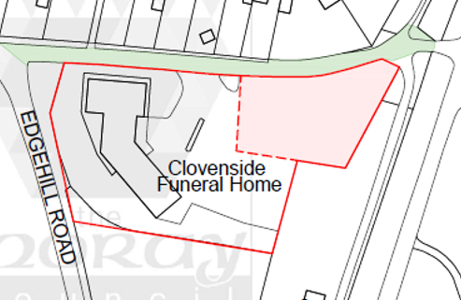

Forres Community Council Query 4.
Where are the boundaries of the Clovenside land under discussion, including access to the graveyard? (FCC and other members of the community have found it difficult to discern the existing and proposed boundaries and ownership/lease/access arrangements from the images and descriptions provided on the website/Facebook page.)

Moray Council Response 4.
The red boundary shows the current boundary contained within the current lease agreement. It remains the same within the sale.

Forres Community Council Query 5.
What are the financial arrangements (including costs and revenues including rent, ownership and lease arrangements) for the land and any building(s) linked to the Clovenside assets under discussion?

Moray Council Response 5.
Current lease between Moray Council and Wm Purves Funeral Director, 99 year lease, started 2002, expiry 2101, current lease amount £12,455 per annum.
Current sub-lease between Wm Purves Funeral Director and Forres Baptist Church, 10 year lease, started 2021, matches lease between MC and Lease Holder.

Forres Community Council Query 6.
How have stakeholders been made aware of this consultation? (E.g. we are aware of the webpage and the Facebook page but, for example, we could not find any information at the site.)

Moray Council Response 6.
The consultation has been advertised on the Moray Council Website, Moray Council Facebook page, in the Forres Gazette, Displayed in the Forres Community Centre and Displayed by the FBC on the premises.

Forres Community Council Query 7.
What other options are there that could allow the Church ongoing use of the land while retaining it as common good land?

Moray Council Response 7.
There are no other options suitable to the current lease holder and FBC.

