School Travel Plan
Template

Moray Council Guidance



What is a school Travel Plan?

Definition:

“A Travel Plan is a document put together by a school or a group of schools which sets out a package of short, medium and long term measures to encourage more children, young people and staff to choose alternatives to the car when making the journey to school”.

It signifies an all-round commitment to develop safer routes to school.

The need for travel plans has arisen due to growing concerns over:

- Increasing congestion associated with the ‘school run’.
- Pupil health concerns concerning inactive lifestyles.
- The need for pupils to gain “road sense” and independence.
- Road safety issues and concerns partly generated by school run related traffic.
- Air quality and climate change.

This template is a guidance document that has been written to help pupils, parents and teachers develop their individual school travel plans. For each school there may be more or less to mention at each stage, so this template can be used as a checklist to be referred to as your own plan develops.

Look for outcomes, circumstances and targets, which suit your school and are realistically achievable.

Travel Plan working group members

The first step is to form a working group to look at your school travel issues. Ideally the group should include representatives from staff, pupils, parents, community members and The Moray Council. This can be an already established group e.g. Your School Health group or might mainly consist of school board / PTA members.
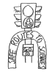
Include photos of the school. You can also include pupil drawings conveying relevant issues at your school.

Why not hold a competition for pupils to design a school travel logo?

1. AIMS

The aims of this travel plan are…

Decide what aims you hope to achieve through your school travel plan. Some will develop as the travel survey and consultation takes place so more can be added as you go along.

Examples:
- To increase awareness amongst pupils, parents and staff about the health, environmental and social consequences of there travel choices.
- To reduce traffic congestion around the school gates.
- Increase the number of children walking and / or cycling to school.
- To improve safety on the journey to school by reducing car use.
- To increase the number of pupils participating in road safety education.
- To review the School Travel Plan on a regular basis.

2. School Travel Plan Action Group

List the teachers, parents, pupils and council staff all involved in the development of the school travel plan

3. School Introduction

- Location
Write a little about where your school is located and what type of school it is, how many pupils there are etc.

(b) Where do your pupils travel from?

(c) Access to the school
How do pupils get into your school, is it surrounded by busy roads, quite roads or residential roads, is there more than one entrance?

- School Times
What time does school start and finish plus any breakfast or after school clubs?

The school has over ……………. people arriving and leaving everyday!

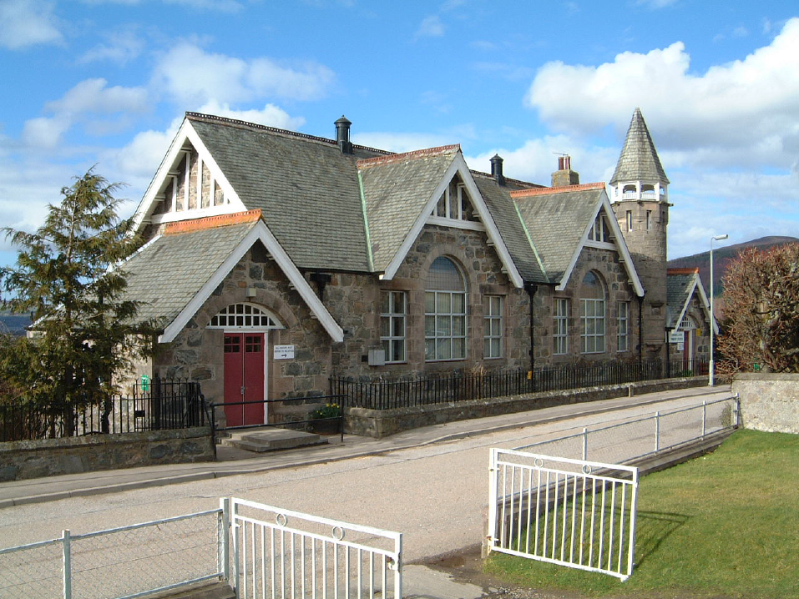
Craigellachie Primary School

4. Present Travel Patterns

In this section include information on school travel issues and give details on what the school has done to aid active travel to school. The questions will help you write down all the necessary information. Leave out questions that are not appropriate.

Arrival
Is there a cloakroom where wet clothes can be left to dry?
Is a secure space for personal items such as clothes, bikes helmets, lights provided?

Car parking
How many car-parking spaces are there available on your site?
Are parents allowed to park on the site?
Are there staff parking issues?
Is there a separate car and pedestrian /cycle exit?
Have there ever been any ‘near misses’ between cars and pedestrians/cyclists on site?
Are car movements on the school site a cause for concern?
Is there a ‘Park and Stride’ site for parents to use?

Access by foot
Are there pedestrian only entrances or shared entrances?
Do you take part in walk to school week/days?

Cycling Access
Cycling is / is not allowed
How many cycle parking spaces are there? Are they covered?
Are they secure?
Is the cycle parking clearly visible from the school buildings?
Does the school offer cycle training? What primary / year group?

Road Safety Education
Is road safety currently taught, and in which primary / year group?

School Crossing Patrol
Does the school have a lollipop person?
What roads do they operate on?

Travel Information
Is travel information available specifically for new pupils?
Do you set out the school ‘policy’ on travel to your school in the school prospectus?
Do you provide route maps for pupils and parents?

Does the School take part in other initiatives?
E.g. Health promoting schools, Eco schools?

Is the school used out of hours?
E.g. for community groups or clubs?
Is traffic generated at times when pupils are entering/ leaving site?
Are pupils/the school affected by this traffic?

Any other details

Tip: insert photo’s, drawings or quotes. Get pupils involved. Be creative.

5. Maps of the school site

Insert a map showing the school site and the local area. You could use:
http://www.multimap.com
http://www.streetmap.co.uk
Or ask your school travel co-ordinator for a map, see contact details at end.
Indicate the location of gates and entrances, cycle racks, car parking, bus stops etc.
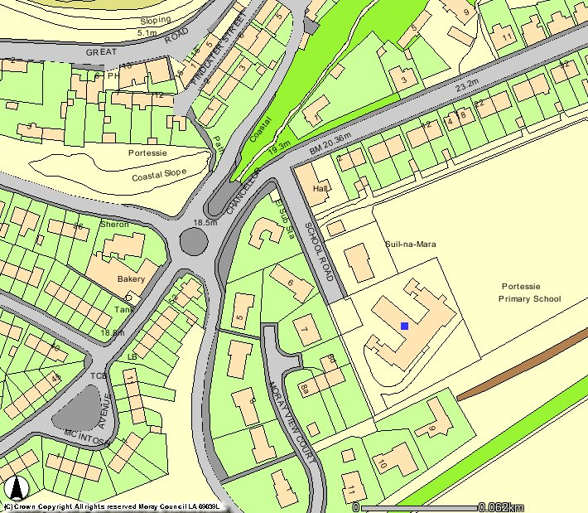

6. Consultation: Surveys and Data

You will need to collect data on how pupils and staff currently travel to the school, how they would like to travel to school if given the choice, and what barriers prevent them from walking and cycling.

Moray Council’s Sustainable Travel Officer can assist with creating a survey (online and hardcopy).

You might feel it appropriate to use the results of the Hands Up Survey with extra information taken from focus groups.

The important thing is to reflect a picture of how things stand, what the issues are and to involve people who use the school.

7. Summary of Survey Findings and Consultations

Here you will need to give details of what you have found out from the surveys and consultations. For example:

The main points we have learnt are:

58% of pupils travel to school by car, but 33 % would like to walk
20% of pupils would cycle if there were secure cycle racks
50% of the school pupils identified the main road difficult to cross

8. Action Plan

Hold a meeting of your Travel Plan Group to discuss the results and decide on actions which may solve the issues and meet the original aims. Have you discovered any extra aims the travel plan can achieve?

What actions/ initiatives would the school like to start? These should be relevant and achievable.

For example;

To encourage sustainable travel:

- Arrange a Walk to School Week event.
- Investigate installing a secure cycle rack.
- Investigate getting a 20mph zone for the road outside the school.
- Recruit more volunteers to help with cycle training.

To promote road safety:

- Use online road safety materials to raise awareness.
- Have the Crossing Patroller speak at assembly at start of school year.
- Support JRSO activity in school.

To raise awareness:

- Keep the local paper aware of work done by the school.
- Publish the Travel Plan on the school website.
- Have a School Travel noticeboard.
- Have school travel on agenda for Parent Council meetings.
9. Action Plan Table

Now write each aim identified and put together an action plan including
- proposed solutions
- who will undertake them
- when they will be completed by

A blank Action Plan Table is attached at the end.
S = Short term
M = Medium term
L = Long term

Here’s an example:

AIM | ACTION | Time-scale | BY WHO | TARGET | Resources / Funding
1 (a)  Increase travel Awareness | Write school travel plan and make it available to all staff, pupils, parents and school community. Publicise STP with a special launch. | S/M | Working group | Produce a School Travel Plan.  Launch event
 | Keep the School Community updated on the school Travel Plan progress and initiatives. | On - going | Head teacher and working group and school secretary | 1 newsletter article per term. An item on staff meetings agenda | Some Resources
 | Develop a school travel notice board | S | Working group | Date …….. | Notice Board
 | Promote National Walk to School Week | M | Working group | 1 a year
(b)  Increase Travel awareness in Classroom activities | Build awareness into curricular and extra-curricular activities.  e.g. an annual travel mode survey in geography lessons | M | Teachers | Ask School Travel Co-ordinator about lesson plans available.
2 (a)  Encourage Sustainable Travel | Hold a poster competition to promote sustainable travel on the school journey. | M | Working group /teachers | Select a poster and display it around the school | A prize for the winner
(b)  Cycling | Hold cycle training courses.  Ask The Police Road safety department. | S | Road safety department | More children trained in safe cycling and the highway code
 | Investigate installation of cycle racks/ provide secure cycle storage. | M | Moray Council | Install racks for both teachers and pupils to use | Funding from Moray Council
(c)  Walking | Identify and recommend safer walking routes to school  - produce a leaflet and encourage pupils and parents to use the routes | M / L | Working Group and Moray Council |  | Funding from Moray Council for improvements
 | Set up a Park and Stride site (use a local car park not too far from the school) | M | Working group and moray council road safety | 10% more pupils walking. Reduce congestion and pollution around school
 | Investigate changes to the school buildings/grounds  e.g. provide a car free entrance, provision of lockers. | M | Moray council | Arrange a meeting with Moray councils traffic engineer | Council  Funding
(d)  Public Transport | Increase publicity of public transport to staff and pupils.  - school travel notice board to include timetables  - train pupils in reading timetables, using buses  - rewrite timetables so easy to read  - Make sure parents / pupils are fully aware of school bus arrangements | M/L | Working Group  Moray Council Public Transport Unit | Information readily available  Attractive display  Inform Parents | Resources
(e)  Car Sharing | Promote car sharing to staff  Promote car sharing to parents living in the same area  - develop a car sharing notice board  - regular information on lifts in Newsletter | M / L | Working Group Staff Meeting
(3)  Improve Safety | Work on measures to reduce the amount of vehicles driving to school and encourage responsible parking (away from the school site). | S/M/L | Working Group | Include travel policies in school prospectus
 | Include STP with development plan for school. | S | Head | Inclusion of STP
 | Investigate physical traffic management measures to improve route to school, improve crossing points  - send in your STP to Moray council Roads Department | M/L | Moray Council  Working group  Local residents | Gain funding to implement physical measures | Funding from moray council
(4)  Monitor, evaluate and review | Decide a Strategy to monitor progress. Assess new work areas and overcome problems. | On going | Working group | Keep the STP up to date.
10. Promotion of the Travel Plan

Members of the school and the general public should be made aware and involved in developing the school travel plan. This can be done by:

- Placing a summery of the plan in the school prospectus
- Provide copies of the plan to new pupils and their parents
- Produce a STP newsletter updating parents and pupils
- Provide relevant information at open evenings
- Think about a school travel plan notice board

11. Monitoring and Review

Give details of how you will monitor and review your school travel plan.

- How often? School Councils Role?
- Annual survey – geography lesson.
- Achievements – publicise.

12. Signed agreement

The headtecher, teachers, parents and pupils of …………………………………….. School agrees to their School Travel Plan and its objectives

Signed: …………………………………………………………… teacher(s)

Signed: …………………………………………………………… parent(s)

Signed: …………………………………………………………… pupil(s)

Now that you have completed you’re School Travel Plan please email an electronic copy to: Andrew.J.Stewart@moray.gov.uk



Blank Action Plan - For your school to use

Aims | Action | Time-scale | By who? | Target | Resources

