An update of Localised poverty in Moray: Bringing together national and local data to identify poverty levels in Moray, showing changes in levels from initial report in March 2023.

Author: Iain Sneddon, Research and Information Officer, Moray Council

EXECUTIVE SUMMARY
Poverty in Moray is rising and doing so at a faster rate than Scotland as a whole. National data (End Child Poverty, 2021/22) for Moray, shows the percentage of children in poverty increased between 2014 and 2022 by 3.2% to 24.1%. Over the same period, Scotland saw a rise of 2.9% to 24.5%. Only seven Scottish Local Authority areas have increased at a greater rate than Moray during this time. In the last year alone (2020/21 -2021/22), Moray has witnessed a 2.8% rise. In terms of ranking nationally against other authorities, Moray has fallen from 20/32 to 14/32 (where 1 is highest). Within our comparator authority group, from being placed 6/8 in 2014 Moray is now placed 2/8 in 2022. Of all Scottish Local Authority areas, only Renfrewshire saw a greater decline in ranking, falling from 25th to 17th.
The average gross full-time hourly pay (earnings by place of work) in Moray in 2023 at £15.94, is significantly less than Scotland (£18.10) and ranks Moray 28/32 of Scottish Local Authorities, where 1 is highest. Moray bucks the trend whereby full-time female workers earn more per hour (£16.09) than their male counterparts (£15.55). Calculations based on weekly wage data, for all employed in Moray, shows an average working week of 40.6hrs, compared with the Scottish average of 38.8 hrs/week. Even by working more hours a week, the average full-time weekly pay in Moray (£647.2) is significantly less than the National average (£702.80). Due to this low wage economy Moray is likely to be less resilient to increases in the cost of living in comparison with many other Scottish Local Authorities, which in turn is a likely contributory factor in the rising levels of child poverty in Moray.
Other societal groups in Scotland do not experience poverty to the same levels as children. Scottish Government statistics show that 21% of working-age people and 15% of pensioners were living in poverty (2019-22). In work poverty is however increasing. Between 2009 and 2012, 52% of working-age people in poverty were within working households, during 2019 and 2022 this had risen to 57%. Similarly, over the same period the proportion of children in poverty from working households, increased from 51% to 69%. This may be indicative of wages and in-work benefits not keeping pace with inflation. With a low wage economy and poverty levels in Moray rising at a faster rate than Scotland it is likely that Moray will be disproportionately affected.
Looking at the national picture, Scotland compares reasonably well against other UK nations. As stated above, 24.5% of children were living in poverty in Scotland in 2021/22. At the same time, in England this rate was 30.8% and Wales 27.9%. In Northern Ireland rates were better at 22.2%. During the ten-year period between 2012 and 2022 levels of child poverty have risen in both Scotland (3.0%) and England (2.6%), whereas in Wales and Northern Ireland have fallen by 4.4% and 4.3% respectively.
Unfortunately, national poverty data does not provide any insight into the levels of poverty within authorities. By using a range of both national and local data, this report aims to show estimated levels of poverty/household financial vulnerability for the smaller geographies in Moray. The level of poverty in Moray, as published in national data, shows 24.1% of Moray children, in 2021/22 were living in poverty. The analysis carried out for Data Zone geographies of Moray shows that estimated levels of poverty range from 0% to 64.8%.

Methodology
Poverty is predominantly based on available household income, as such most of the data sets used to estimate levels in Moray, are based on benefits and advice services relating to income. In addition to income-based data, Scottish Index of Multiple Deprivation (SIMD2020) data has been included in the analysis, but cognisance should be taken in reference to SIMD2020 data as it identifies geographic areas where deprivation is highest, it does not identify households or individuals.
The National Records of Scotland (NRS) was used to provide household, population and urban/rural contextual data. Children Living in Low-income Families data, for the period 2021/22, was extracted at 0-15 age range. National Child Poverty data, at Local Authority level, provides a combined figure for children aged 0-15, and 16–19-year-olds, if they remain within non-higher education. As no figure is available for the number of children remaining in education it is not possible to make population comparisons. To allow for direct comparisons with population data, the 0-15 range has been used in calculations to estimate Child Poverty. The data sources used, both national and local, are detailed in Appendix 1.
Scotland is divided into a number of smaller geographies, from Postcodes to Output Areas to Data Zones and then to Intermediate Zones, before reaching Local Authority level. Data has been extracted from sources at a variety of geography sizes and accumulated to both Data Zone and Intermediate Zone level. For some data sets it was possible to isolate child data, for example the Moray Food plus provides data for claimants by age of all individuals living household, allowing for a more specific analysis. Unfortunately, there are insufficient data sets to allow the compilation of tables which would provide analysis solely for children living in households.
All data was transferred into an Excel Workbook with a field for every element of data. Data was standardised to a percentage by using population data for the geographic areas. Each data field was then ranked (1-126) with ranking 1 being the worst value. No weighting was applied to any field with all treated equally. To provide an overall ranking for each data zone all field rankings were totalled.
With the exception of SIMD2020, data is from the period 2021-2023 (Source dependent). All data used was from the most recent time period available.
A special thanks to all the providers of local data, without which it would not have been possible to produce such a detailed Poverty/household financial vulnerability information within Moray.

data limitations
It is recognised that other factors can have an impact on household finances such as:
- Increased transport costs and access to public transport.
- Increased food prices in more rural areas.
- Access to mains gas and cost of alternative fuels.
- Properties in the most rural locations have a higher proportion of older, less well insulated, dwellings.
These factors could have a major bearing on rural poverty, however data is not available at smaller geography level and where it does exist at Local Authority level is significantly outdated and would not contribute to the analysis.

TABLES
Intermediate Zone level was chosen to as the preferred geography to display the data within the main table (Table 2) as it shows the extent of poverty/ financial vulnerability in one table with 24 rows, as opposed to Data Zone level where data would be in 126 rows. Where data relates to Moray, comparator authority data has been used to provide context.
The data listed in Table 2 is ranked from top to bottom in order of accumulated score ranking, with the highest levels of poverty/ financial vulnerability at the top. For ease of reading, the accumulated scores are not provided within the tables. The columns with ‘Child Poverty Estimates’ do not always flow sequentially from most to least; this is due to the use of accumulated scores as a ranking measure as opposed to ‘Estimated Child Poverty’. Where available comparisons are made with data in the previous report to show changes in levels and rankings.

TABLE 1: Urban / rural demographics of moray
Moray is classed as a rural Local Authority. Nationally 17% of the population live in rural locations, in Moray the figure is significantly higher at 41.3%. In Moray, 39.3% of children aged 0-15 live in rural locations, indicating a lower population density living rurally for this age group. Of the 9,679 children living in urban areas, 2,539 (26.2%) are estimated to be living in Child Poverty. In comparison, the figure for those living rurally is lower at 20.9% (1,310). As Table 1 shows of the percentage of all child poverty in Moray, 66% of these children live in urban areas. As this figure is higher than the general population demographics for this age group, it is fair to say that child poverty levels are higher in urban areas.
Table 1: Urban / Rural population demographics
Urban / Rural Population Demographics in Moray
 | Population |  | 0-15 |  | Data Zones |  | Estimated Child Poverty
 | Number | % | Number | % | Number | % | Number | % | % of all Poverty
Urban | 56,562 | 58.7% | 9,679 | 60.7% | 75 | 59.5% | 2,539 | 26.2% | 66.0%
Rural | 39,848 | 41.3% | 6,262 | 39.3% | 51 | 40.5% | 1,310 | 20.9% | 34.0%
TOTALS | 96,410 |  | 15,941 |  | 126 |  | 3,849 | 24.1%

Table 2: analysis by intermediate zone
Moray has 24 Intermediate Zones with an average population of 4,000 residents and an average of 664 children aged 0-15. The top seven ranked Intermediate Zones are all urban and whilst having 31.1% of the 0-15 population, they also have 43.3% (1,666/3,849) of all Moray children estimated to be living in poverty. The average SIMD2020 decile ranking shows that both the most and least deprived areas are urban. The average ranking for all urban Intermediate Zones is 6, with rural Intermediate Zones ranking 7, showing urban Intermediate Zones as more deprived and evidencing the linkages between deprivation and poverty. These average Intermediate Zone rankings are based on the aggregation of Data Zone rankings and don’t show the differences between urban and rural areas as accurately as Data Zone level data does. Urban areas of Moray have 10 Data Zones within the most 30% (Deciles 1-3) deprived areas of Scotland. Conversely rural areas have only one.
Of the 24 Intermediate Zones, rankings for nine have worsened, nine have improved and six have remained the same since the initial analysis was carried out in late 2022. The top seven Intermediate Zones remain the same, but Elgin Cathedral to Ashgrove and Pinefield has replaced Forres South West and Mannachie as having the lowest accumulated score. Although this would appear to show little change from the previous year the estimated levels of poverty/ financial vulnerability have increased significantly in all but five Intermediate zones. The percentage change in Estimated Relative Child Poverty is expressed as an increase or decrease from the number of children recorded in the previous year (2020/21). Significant rises have been witnessed in Elgin Cathedral to Ashgrove and Pinefield (12.1%) and Lossiemouth East and Seatown (13.6%). Overall, the data shows the estimated number of children aged 0-15 living in poverty has increased by 470 children from 3,379 to 3,849 (13.9% increase in children) between 2020/21 and 2021/22.

Table 2 - Poverty/ Financial vulnerability in Moray by Intermediate Zone
INTERMEDIATE ZONES (HOUSEHOLD DATA) IN ORDER OF OVERALL RANKING (1=WORST, 24=BEST)
Ranking | Intermediate Zone Name | ASG Area | Average Urban/Rural 2-Fold | Total 0-15 Population | Average SIMD2020 Decile | Previous Ranking | Change in Ranking | % Estimated Relative Child Poverty 2021/22 | Estimated number of Children (0-15) in Relative Child Poverty 2021/22 | % Change in Estimated Relative Child Poverty | Increase/Decrease in number of Children (0-15) in Relative Child Poverty 2020/21 - 2021/22
1 | Elgin Cathedral to Ashgrove and Pinefield | Elgin Academy | 1 | 722 | 4 | 3 | 2 | 40.2% | 290 | 12.1% | 88
2 | New Elgin East | Elgin High School | 1 | 811 | 5 | 2 | - | 37.5% | 304 | 1.5% | 12
3 | Forres South West and Mannachie | Forres Academy | 1 | 812 | 5 | 1 | -2 | 34.4% | 280 | 1.2% | 10
4 | Buckie Central East | Buckie High School | 1 | 602 | 5 | 4 | - | 32.4% | 195 | 1.0% | 6
5 | Keith and Fife Keith | Keith Grammar School | 1 | 681 | 5 | 5 | - | 33.1% | 226 | 2.4% | 16
6 | Elgin Bishopmill East and Ladyhill | Elgin Academy | 1 | 527 | 5 | 6 | - | 29.9% | 157 | 6.2% | 33
7 | Lossiemouth West | Lossiemouth High School | 1 | 805 | 6 | 7 | - | 26.6% | 214 | 6.3% | 51
8 | Cullen, Portknockie, Findochty, Drybridge and Berryhillock | Buckie High School | 2 | 843 | 7 | 9 | 1 | 30.9% | 261 | 4.1% | 35
9 | Fochabers, Aultmore, Clochan and Ordiquish | Milne's High School | 2 | 444 | 6 | 8 | -1 | 23.0% | 102 | -0.8% | -3
10 | Buckie West and Mains of Buckie | Buckie High School | 1 | 860 | 6 | 12 | 2 | 17.2% | 148 | 4.7% | 41
11 | Lhanbryde, Urquhart, Pitgavney and seaward | Elgin Academy | 2 | 610 | 6 | 13 | 2 | 24.3% | 148 | 4.5% | 27
12 | Mosstodloch, Portgordon and seaward | Buckie High School | 2 | 489 | 7 | 11 | -1 | 21.6% | 106 | 1.3% | 6
13 | New Elgin West | Elgin High School | 1 | 694 | 7 | 15 | 2 | 19.3% | 134 | 1.5% | 10
14 | North Speyside | Speyside High School | 2 | 533 | 7 | 16 | 2 | 19.8% | 106 | 0.5% | 3
15 | Lossiemouth East and Seatown | Lossiemouth High School | 1 | 454 | 7 | 17 | 2 | 22.3% | 101 | 13.6% | 62
16 | Forres Central East and seaward | Forres Academy | 1 | 396 | 7 | 14 | -2 | 19.3% | 76 | 3.1% | 12
17 | Elgin Bishopmill West and Newfield | Elgin Academy | 1 | 588 | 7 | 22 | 5 | 17.2% | 101 | 7.1% | 42
18 | South Speyside and the Cabrach | Speyside High School | 2 | 628 | 6 | 10 | -8 | 21.7% | 136 | -2.1% | -13
19 | Heldon West, Fogwatt to Inchberry | Milne's High School | 2 | 1234 | 6 | 23 | 4 | 16.2% | 200 | 3.1% | 38
20 | Rural Keith and Strathisla | Keith Grammar School | 2 | 508 | 6 | 19 | -1 | 19.0% | 96 | -0.1% | -1
21 | Findhorn, Kinloss and Pluscarden Valley | Forres Academy | 2 | 675 | 7 | 18 | -3 | 27.2% | 183 | 5.3% | 36
22 | Burghead, Roseisle and Laich | Lossiemouth High School | 2 | 844 | 8 | 21 | -1 | 16.0% | 135 | -1.0% | -9
23 | Rafford, Dallas, Dyke to Dava | Forres Academy | 2 | 744 | 7 | 20 | -3 | 16.4% | 122 | 0.3% | 2
24 | Elgin Central West | Elgin Academy | 1 | 437 | 9 | 24 | - | 6.2% | 27 | -7.6% | -33
 |  |  | TOTALS | 15941 |  |  |  | 24.1% | 3849 |  | 470

TABLE 3: SIMD2020 Moray from a National Perspective
SIMD2020 provides a ranking for all of Scotland’s 6,976 Data Zones, allowing for comparisons with other Scottish Local Authorities. Nationally, Moray is not seen as a deprived Local Authority as the majority of the population (51.8%) live in the 40% least deprived areas. In comparison, Scotland has a smaller proportion (41.2%) living in the 40% least deprived areas. The colour coding in the in Table 3 provides a visual of highs and lows (Red – Green).
From a national perspective, 7.8% of the 0-15 population in Moray live in the 30% most deprived (Deciles 1-3) areas, yet 14.5% of all children in poverty live in these areas. In contrast, the 30% least deprived of areas (Deciles 8-10) have almost four times more children but 16.2% of all children living in poverty, evidencing the strong linkages between deprivation and poverty. Although poverty density is higher in the most deprived areas, the vast majority (85.5%) of children in poverty live out with the most deprived areas. This would appear to beg the question as to whether it is better to direct resources to areas with the highest need but with the smallest proportion of children in poverty or, direct the same resources more widely to mitigate poverty for the vast majority of children. It doesn’t however show what Moray looks like internally.
Table 3 -Population and child poverty by SIMD2020 Decile (National Rankings)
POPULATION DATA BY SIMD2020 DECILE (1= MOST DEPRIVED, 10= LEAST DEPRIVED)
SIMD DECILE | % of DATAZONES | % of POPULATION | % of 0-15 (OVERALL) population | % of 0-15 (DECILE) population) | Estimated number of Children (0-15) in Relative Child Poverty 2021/22 | % Estimated Relative Child Poverty by SIMD Decile 2021/22
1 | 0.8% | 0.7% | 1.0% | 24.8% | 65 | 39.9%
2 | 2.4% | 2.0% | 2.2% | 18.3% | 166 | 47.3%
3 | 5.6% | 4.6% | 4.6% | 16.5% | 328 | 44.8%
4 | 11.1% | 9.2% | 10.1% | 18.1% | 585 | 36.3%
5 | 13.5% | 14.1% | 14.7% | 17.3% | 757 | 32.3%
6 | 18.3% | 17.7% | 16.7% | 15.6% | 647 | 24.4%
7 | 22.2% | 20.7% | 20.0% | 16.0% | 678 | 21.3%
8 | 14.3% | 17.8% | 17.7% | 16.4% | 436 | 15.5%
9 | 5.6% | 6.4% | 6.3% | 16.3% | 89 | 8.9%
10 | 6.3% | 6.9% | 6.8% | 16.3% | 99 | 9.1%

Table 4: MORAY internal deprivation
The national perspective can only show how Moray compares with other areas in Scotland, it is not able to provide an internal picture of Moray. Using the same approach as SIMD2020, but applying it internally to Moray’s 126 data zones, provides a more accurate picture of deprivation within Moray.
By ranking each of Moray’s Data Zones from 1-126 they can be placed into ‘Moray’ Deciles (10% of Data Zones per Decile), showing the internal deprivation of Moray. By doing so, in theory, it would be expected that 10% of the population would live in each decile. Deciles 1-7 broadly follow this Population distribution, but err on the lower side, whereas deciles 8-10 do not, they all have higher population levels than would be expected. The 0-15 population follow a similar trend with a higher proportion living in the 30% least deprived in comparison to those in the 30% most deprived. These two factors show that even internally, Moray is inclined to be less deprived. As with the national perspective, the population density locally is weighted towards those in the 30% most deprived. Families living in the most deprived areas are more likely to have more children and there is a higher likelihood of single parent families. The most significant difference between the national and local perspective is the number of children estimated to be living in poverty in the most deprived areas of Moray, these children are not evenly distributed within deciles. 48% of all Moray children estimated to be living in poverty are living in the 30% most deprived of areas of Moray, in stark contrast to the 14.5% identified by using the national SIMD ranking. Both the number and proportion of children estimated to be living in poverty show a uniformed trend with more children and an increasing proportion living in poverty as levels of deprivation increase. Contrary to the indication of ’whether it is better to direct resources to areas with the highest need but with the smallest proportion of children in poverty or, direct the same resources more widely to mitigate poverty for the vast majority of children.’ raised by analysis at a national perspective, the local perspective analysis shows the justification to direct resources to the areas of highest deprivation, as this is where the greatest impact of mitigating poverty can be made.
Table 4 - Moray Internal Deprivation
POPULATION DATA BY MORAY RANKING (1= MOST DEPRIVED, 10= LEAST DEPRIVED)
SIMD DECILE | % of DATAZONES | % of POPULATION | % of 0-15 (OVERALL) population | % of 0-15 (DECILE) population) | Estimated number of Children (0-15) in Relative Child Poverty 2021/22 | % Estimated Relative Child Poverty by Moray Ranking 2021/22
1 | 10.0% | 9.0% | 10.4% | 19.0% | 758 | 45.7%
2 | 10.0% | 9.3% | 10.9% | 19.3% | 625 | 36.0%
3 | 10.0% | 8.7% | 8.6% | 16.4% | 463 | 33.7%
4 | 10.0% | 8.8% | 8.8% | 16.5% | 367 | 26.1%
5 | 10.0% | 9.8% | 9.1% | 15.3% | 407 | 28.1%
6 | 10.0% | 10.0% | 8.7% | 14.5% | 309 | 22.2%
7 | 10.0% | 9.0% | 9.2% | 16.8% | 284 | 19.4%
8 | 10.0% | 12.8% | 13.4% | 17.3% | 324 | 15.1%
9 | 10.0% | 10.6% | 9.1% | 14.2% | 186 | 12.8%
10 | 10.0% | 11.9% | 11.8% | 16.4% | 127 | 6.8%
Figure 1 shows the distribution of children living in poverty within Moray and the number of children in poverty in each Moray decile. There are almost three times more children in poverty living in the 30% (1,846) most deprived areas than there are living in the 30% (637) least deprived. The linkages between deprivation and poverty are clear, as Internal deprivation decreases so does proportionate poverty. This provides the strongest argument for directing resources to mitigate the impact of poverty towards those areas of highest deprivation within Moray.
Figure 1 - Poverty & Internal Deprivation Relationship

figures 2, 3 & 4: Moray vs comparator authorities
Figure 2 shows where Moray ranks in relation to its Comparator Authorities. In 2021/22 Moray ranks as the second highest within our comparator group. This differs significantly from ranking sixth highest in 2014/15. None of our comparator authorities have declined in nationwide ranking to the same extent as Moray over the period. East Lothian has seen the largest change in ranking, from having the highest levels of poverty in 2014/15 it now has the second lowest in the comparator group. What has happened in East Lothian that hasn’t happened in Moray? Stirling had the lowest level of poverty in 2014/15 and still has the lowest levels within our comparator group.
Figure 2 - Moray vs Comparator Authorities (% Poverty)
Ranking | Scotland | 24.5%
1 | Angus | 24.2%
2 | Moray | 24.1%
3 | Scottish Borders | 23.4%
4 | Highland | 22.8%
5 | Midlothian | 22.7%
6 | Argyll & Bute | 21.7%
7 | East Lothian | 21.1%
8 | Stirling | 20.8%
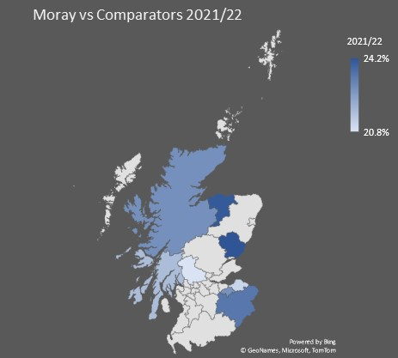

As Figure 3 shows, the year-to-year poverty trend is not uniformed, unpredictable external factors can have a huge influence on levels, as can be seen from the dip in poverty during the pandemic (2020/21). As such Predicting/ Forecasting poverty levels are only estimates. The estimates shown in Figure 3 are based upon a 3-year rolling average over the period from 2014-22 and projecting these averages forward to 2030. Factoring in these averages, estimated levels in Moray in 2030 (25.6%) will be 3% higher than our comparator median. If the cost of living continues to rise, it is likely that child poverty will rise at a rate greater than currently forecast.
Figure 3 - Poverty Forecast 2022/23 - 2029/30

Figure 4 shows how child poverty levels have changed between 2014 and 2022 within our comparator authority group. Over this period child poverty in Moray has risen at a greater rate (3.2%) in comparison with the average rise within our comparators (1.3%). The darker map colours highlight the extent of the rises for Moray and our comparator authorities.
Figure 4 - Moray vs Comparator Authorities (Change in Poverty 2014-22)
Ranking | Scotland | 2.9%
1 | Moray | 3.2%
2 | Angus | 3.1%
3 | Scottish Borders | 2.5%
4 | Highland | 1.4%
5 | Stirling | 1.2%
6 | Argyll & Bute | 1.1%
7 | Midlothian | 0.9%
8 | East Lothian | -0.8%
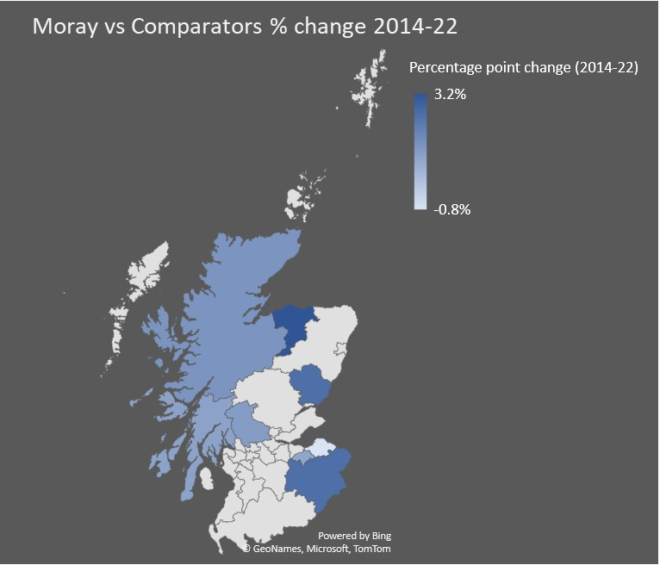

Figures 5 & 6: how does compare with all scottish local authorities
Poverty in Scotland varies significantly, comparator authorities are highlighted in blue within the supporting table. One in three children in Glasgow city are in poverty compared with one in seven in East Renfrewshire, yet the two authorities share a border. Moray, in 2021/22 is placed as having the 14th highest levels of child poverty of Scotland’s 32 Local Authorities, this is in stark contrast to being placed 20th in 2014/15. From having a rate 0.8% less than Scotland in 2014/15 the difference has narrowed to 0.4% 2021/22. SIMD2020 data shows that in Moray 7.8% of the 0-15 population live in the 30% most deprived areas of Scotland, nationally the figure is 26%.
Figure 5 - Moray vs All Scottish Local Authorities (% Poverty)
Ranking | Scotland | 24.5%
1 | Glasgow City | 32.0%
2 | North Ayrshire | 29.0%
3 | Clackmannanshire | 28.3%
4 | West Dunbartonshire | 27.6%
5 | East Ayrshire | 27.2%
6 | Dundee City | 27.1%
7 | North Lanarkshire | 26.6%
8 | Fife | 26.1%
9 | Dumfries and Galloway | 26.0%
10 | Falkirk | 25.3%
11 | South Ayrshire | 24.4%
12 | Inverclyde | 24.4%
13 | Angus | 24.2%
14 | Moray | 24.1%
15 | West Lothian | 23.9%
16 | Scottish Borders | 23.4%
17 | Renfrewshire | 23.3%
18 | South Lanarkshire | 22.8%
19 | Highland | 22.8%
20 | Midlothian | 22.7%
21 | Perth and Kinross | 21.9%
22 | Argyll and Bute | 21.7%
23 | East Lothian | 21.1%
24 | Stirling | 20.8%
25 | Aberdeen City | 20.5%
26 | Orkney Islands | 20.1%
27 | Western Isles | 19.8%
28 | City of Edinburgh | 19.5%
29 | Aberdeenshire | 16.0%
30 | Shetland Islands | 15.4%
31 | East Dunbartonshire | 14.9%
32 | East Renfrewshire | 14.4%
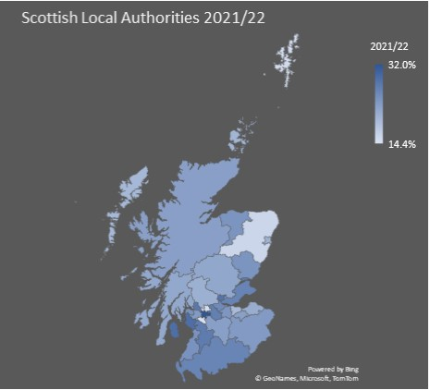

Figure 6 shows how child poverty levels in Scotland have changed between 2014 and 2022 for Local Authorities. Moray has witnessed the 8th highest increase over this period. With the exception of Dundee City all other authorities with higher increases are within the central belt.
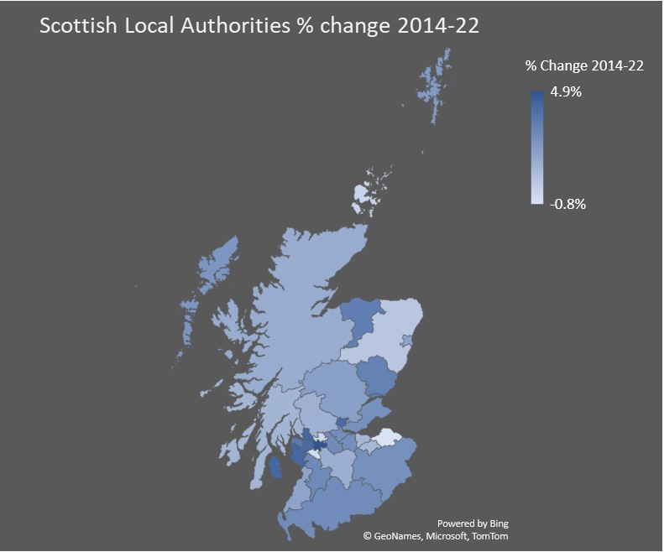
Figure 6 - Moray vs All Scottish Local Authorities (% Poverty) (Change in poverty 2014-22)
Ranking | Scotland | 2.9%
1 | Glasgow City | 4.9%
2 | West Dunbartonshire | 4.2%
3 | North Ayrshire | 4.2%
4 | Clackmannanshire | 4.1%
5 | Renfrewshire | 4.0%
6 | Inverclyde | 3.5%
7 | Dundee City | 3.3%
8 | Moray | 3.2%
9 | Angus | 3.1%
10 | East Ayrshire | 2.8%
11 | North Lanarkshire | 2.7%
12 | Dumfries and Galloway | 2.7%
13 | Falkirk | 2.7%
14 | West Lothian | 2.6%
15 | Fife | 2.5%
16 | Scottish Borders | 2.5%
17 | Western Isles | 2.3%
18 | Shetland Islands | 2.1%
19 | Perth and Kinross | 2.0%
20 | South Ayrshire | 1.8%
21 | Aberdeen City | 1.8%
22 | Highland | 1.4%
23 | South Lanarkshire | 1.3%
24 | Stirling | 1.2%
25 | Argyll and Bute | 1.1%
26 | Midlothian | 0.9%
27 | City of Edinburgh | 0.9%
28 | Aberdeenshire | 0.4%
29 | Orkney Islands | -0.2%
30 | East Dunbartonshire | -0.3%
31 | East Renfrewshire | -0.5%
32 | East Lothian | -0.8%

conclusion
Child poverty in Moray is on a rising trend and at 24.1% in 2021/22 is the highest level recorded between 2014 and 2022. In 2021/22, there was an estimated 3,849 children aged 0-15 living in ‘Relative Poverty’, an increase of approximately 470 children from the previous year. Poverty is defined by available household income, if a child is in poverty any adult in the household is also in poverty. If the Scottish average poverty proportions for working aged adults (21%) and pensioners (15%) were to be applied to the population of Moray in 2021/22, there were an estimated 19,455 people living in poverty, 20.2% of the population.
The ‘Bounce back’ from the initial COVID pandemic period (2020/21) is the likely cause of the significant increase between 2020/21 and 2021/22. If this period were to be excluded child poverty would show a more uniformed rising trend. Moving forward, the increase in the cost of living since 2021/22 is likely to have an impact in 2022/23 and 2023/24, so it would be no surprise if poverty levels in these years exceed forecast levels.

APPENDIX 1: DATA SOURCES

NATIONAL SOURCES
- National Records of Scotland (NRS): Mid-year population estimates by Data Zone, 2021
- National Records of Scotland (NRS): Small area household estimates by Data Zone, 2021
- Department of Work and Pensions (DWP) Stat-Xplore: Children living in Low Income Families, 2021/22
- Department of Work and Pensions (DWP) Stat-Xplore: Carers Allowance, July 2023
- Department of Work and Pensions (DWP) Stat-Xplore: Disability Living Allowance (DLA), July 2023
- Department of Work and Pensions (DWP) Stat-Xplore: Personal Independence Payment (PIP), July 2023
- Department of Work and Pensions (DWP) Stat-Xplore: Universal Credit, July 2023
- Department of Work and Pensions (DWP) Stat-Xplore: Pension Credit, July 2023
- Scottish Index of Multiple Deprivation (SIMD), 2020
- End Child Poverty, 2021/22
- Official Census and Labour Market Statistics (NOMIS), December 2023

LOCAL SOURCES (Benefits and Money Advice Service)
- Council Tax Reduction (CTR), 2022/23
- Housing Benefit (HB), 2022/23
- Flexible Food Fund (FFF), 2022/23
- Free School Meals (FSM) SEEMIS Snapshot, June 2023
- MAMS Income Maximisation (IM), 2023/23
- MAMS Money Advice (MA), 2022/23
- MAMS Welfare Benefits (WB), 2022/23
- Discretionary Housing Payments (DHP), 2022/23
- Education Maintenance Allowance (EMA), 2022/23
- Scottish Welfare Fund (SWF), 2022/23
- Crisis Grants, 2022/23
- Community Care Grants, 2022/23
- Moray Food Plus, 2022/23

The definition of poverty in this report relates to Relative Poverty / Child Poverty – described as: People / Children living in households whose equivalised income is below 60% of UK median income in the same year after housing costs (AHC).
Official Census and Labour Market Statistics (NOMIS)
A data zone contains between 500 to 1,000 people. They are made up from groups of census output areas. There are 126 Data Zones in Moray.
Each postcode covers an average of 15 properties. Over 6,100 postcodes exist in Moray.
Census Output Areas (OAs) and Super Output Areas (SOAs) are geographical areas developed from Census 2001 information. OAs are the smallest unit, covering around 125 households.
Larger geographical areas containing an average of around 4,000 people. There are 24 Intermediate Zones in Moray.
SIMD2020 ranks every Data Zone from Decile 1 to 10, with 1 having the highest levels of deprivation. An average is taken from the Data Zone total to provide an Intermediate Zone average.

