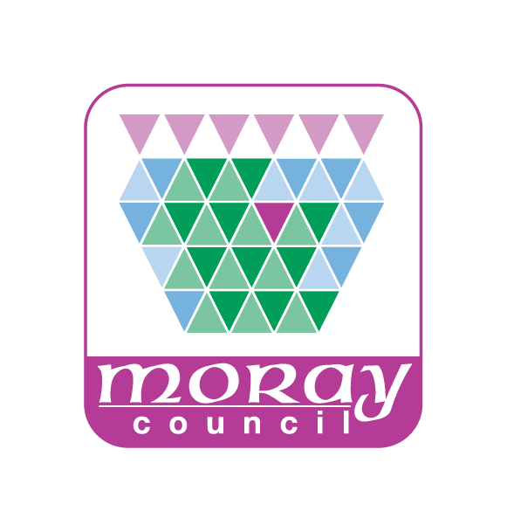 | DO I NEED PERMISSION TO OPERATE A SHORT TERM LET?
If you are considering or are already operating a short term let, you should be sure that you have obtained all the necessary permissions to enable you to operate within the law.

Each case requires individual consideration and assessment of whether a Planning Application is required based on the Town and Country Planning (Scotland) Act 1997 as amended.

Completing this questionnaire will enable Moray Council as Planning Authority to advise you if planning consent is required. Please note there is a fee for the provision of this service which you will be notified of on receipt of the completed form

Name
Address
Telephone No
E-mail
Address of short term let property

Is the property a house or flat |  | HOUSE |  | FLAT
Is the short term let already operating? |  | EXISTING |  | PROPOSED
Where is the short term let operated from? e |  | WHOLE HOUSE  LET |  | ROOM IN HOUSE  (if yes is breakfast supplied)
 |  | ANNEXE |  | SEPARATE STRUCTURE
Are the rooms/buildings/structures solely used for this purpose?
How long has the short term let been operating from this property?

Have any alterations/extensions been done or are proposed to the property in relation to the short term let?
Is the site subject to any planning conditions which restrict the use? If yes, provide details
Confirm if the property has any shared/communal areas including shared access, parking, and garden areas.
NOTE: If you are carrying out alteration or extensions to the property, you should provide a location plan and dimensioned sketches with this questionnaire.
Is there any signage displayed at the property that relates to the short term let?
Please provide any further relevant information.
For example, further information about the short term let that you think might be relevant
(Please use separate sheet if required)
Send to | Development Management  Environmental Services  Council Offices  High Street Elgin  Moray  IV30 1BX
E-mail | Development.control@moray.gov.uk
Note: This questionnaire only relate to the requirement of Planning Permission and Consents. You should discuss any other consent that may be required such as licensing and building warrants with the relevant departments within Moray Council. There is a building standards duty officer available daily between 2 and 4 o’clock through the Contact centre on 03001234561.
Our response is based on the information provided in this questionnaire, however should the nature or level of the business change, you should contact us again.

