

**Environmental Monitoring Report – Falconer Museum & Store**

**19th September 2024**

**02/05 – 19/09/2024 data**

**Handheld thermo-hygrometer weekly readings**

|  |  |  |
| --- | --- | --- |
| ***Museum Ground Floor (GF)*** | 18.4°c | 59.5% |
| ***Museum mezzanine*** | 18.4°c | 66.8% |

|  |  |  |
| --- | --- | --- |
| ***Museum Archaeological Cabinet – off data logger*** | 18.2°c | 62.6% |

|  |  |  |
| --- | --- | --- |
| ***Museum store GF*** | 15.7°c | 71.0% |
| ***Museum store 1st Floor*** | 16.1°c | 65.5% |

**Data logger download data**

**Museum**

|  |  |  |
| --- | --- | --- |
| ***Museum*** | **Temp °c** | **Relative Humidity %** |
| ***Min*** | 17.4°c | 45.2% |
| ***Max*** | 23.3°c | 66.4% |
| ***Average*** | 19.3°c | 57.0% |

|  |  |  |
| --- | --- | --- |
| ***Museum Archaeological Cabinet*** | **Temp °c** | **Relative Humidity %** |
| ***Min*** | 16.2°c | 45.2% |
| ***Max*** | 23.0°c | 56.9% |
| ***Average*** | 19.0°c | 52.5% |

See graph below

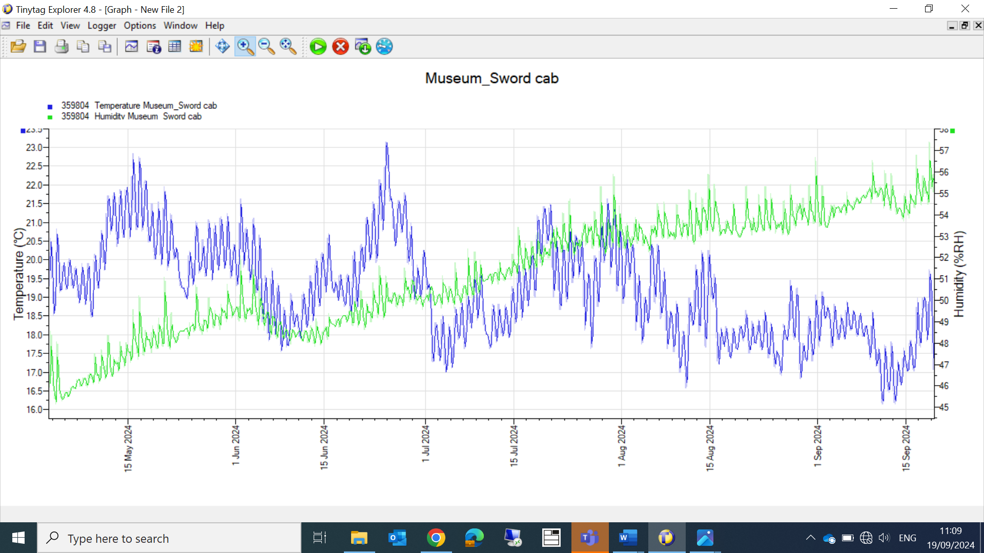

Museum Store

|  |  |  |
| --- | --- | --- |
| ***Museum Store GF*** | **RH%** | **Temp °c** |
| ***Min*** | 59.8% | 14.1°c |
| ***Max*** | 72.5% | 18.7°c |
| ***Average*** | 68.0% | 16.5°c |

|  |  |  |
| --- | --- | --- |
| ***Museum Store 1st – stack 6*** | **RH%** | **Temp °c** |
| ***Min*** | 53.4% | 13.1°c |
| ***Max*** | 70.4% | 21.3°c |
| ***Average*** | 59% | 17.0°c |

Note

Museum Store 1st floor; been quite humid for sometime, I would recommend a dehumidifier is installed.

Traps

Falconer museum

GF

Guitar cabinet 2 slaters

Falconer bust 0

Mezzanine

Mirror, Trap 3 17 slaters (poss due to damp external walls)

Soldier, Trap 4 2 slaters, 2 silverfish

Museum store

All blunder and moth traps

Richard Aitken ACR

High Life Highland Conservation Service

High Life Highland & Registration Centre.

Action

Tyvek tape for cabinets in museum