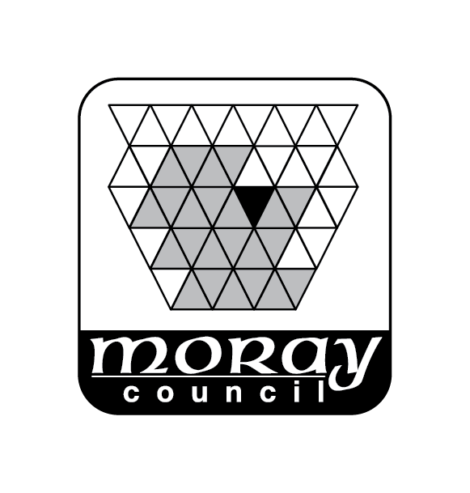
Environmental Services Department
Moray Council
PO Box 6760
Elgin
Moray
IV30 9BX
Telephone: 0300 1234561
Email: development.control@moray.gov.uk

Application for Planning Certificate(s)
THE CIVIC GOVERNMENT (SCOTLAND) ACT 1982
(LICENSING OF SHORT-TERM LETS) ORDER 2022 AS AMENDED

(Please tick relevant box)
Provisional Planning Certificate - £68.00

Planning Certificate -£68.00
(This Certificate cannot be issued unless a Provisional Certificate has been issued)

Name of Applicant

Address of Applicant
Address of Premises to which the Certificate Relates
Telephone No.
Mobile No.
Email
Name of Agent (if applicable)
Address

Telephone Number
Mobile
Email
Planning ref no |  |  | Date of decision
Certificate Lawfulness ref no* |  |  | Date of decision
*Certificate of Lawfulness under Section 150 of the Town and Country Planning (Scotland) Act 1997
Signature |  |  | Date

Please send completed form to Development Services Moray Council PO Box 6760 Elgin Moray
IV30 9BX

Email: development.control@moray.gov.uk

