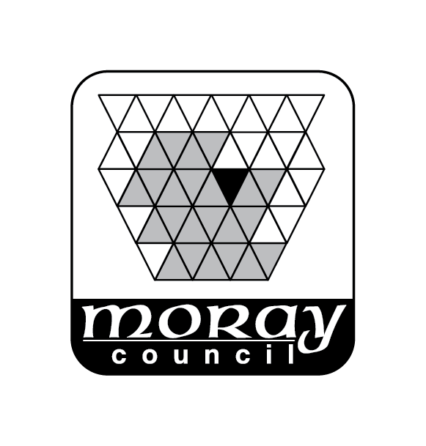
Environmental Services Department
Moray Council
PO Box 6760
Elgin
Moray
IV30 9BX
Telephone: 0300 1234561
Email: buildingstandards@moray.gov.uk

Application for Building Standards Certificate

THE CIVIC GOVERNMENT (SCOTLAND) ACT 1982
(LICENSING OF SHORT-TERM LETS) ORDER 2022 AS AMENDED

Name of Applicant

Address of Applicant
Address of Premises to which the Certificate Relates
Telephone No.
Mobile No.
Email
Name of Agent (if applicable)
Address

Telephone Number
Mobile
Email
Building Warrant Ref no |  |  | Date issued
Completion Certificate |  |  | Date issued
Signature |  |  | Date

Fee - For current fee information please see our website www.moray.gov.uk/buildingstandards

Please send completed form to Building Standards Moray Council PO Box 6760 Elgin Moray
IV30 9BX

Email: buildingstandards@moray.gov.uk

