Environmental Monitoring Report – Falconer Museum & Store
29th February 2024
Please note these readings cover a six month period, I was unavailable for the August visit.
Handheld thermo-hygrometer weekly readings
Museum Ground Floor (GF) | 18.3°c | 43.2%
Museum mezzanine | 18.3°c | 40.0%

Museum store GF | 15.0°c | 48.0%
Museum store 1st Floor | 15.2c | 43.0%

Data logger download data
Museum
Museum | Temp °c | Relative Humidity %
Min
Max
Average
Low battery, no data, replaced the battery.

Museum Archaeological Cabinet | Temp °c | Relative Humidity %
Min | 13.1°c | 42.6%
Max | 18.9°c | 46.6%
Average | 16.0°c | 44.7%
See graph below
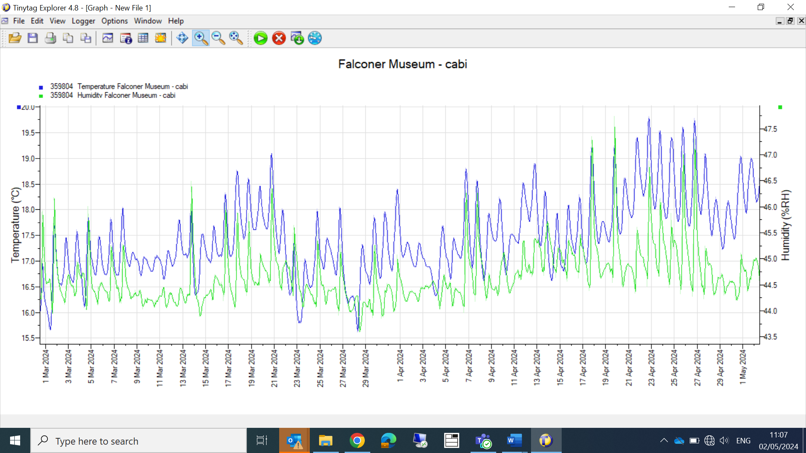
The humidity appears under control, with minimum fluctuation between 43.6 and 47.6% relative humidity.

Museum Store
Museum Store GF | Temp | Humidity
Min | 13.1c | 42.6%
Max | 18.9c | 46.6%
Average | 16c | 44.7%
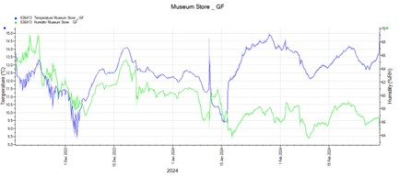
Museum Store 1st F-silica gel ailse | Temp | Humidity
Min | 8.1c | 50.5%
Max | 14.9c | 69.7%
Average | 12.5c | 59%

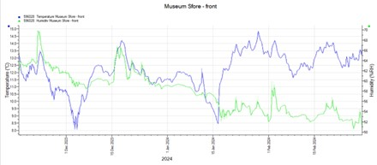
The annual agreement in place with Moray Council, now agrees to site visits every two months from April to October and one in January or February, previously the agreements covered every three months. Insects and internal environments are more stable between October & April.
Richard Aitken ACR
High Life Highland Conservation Service
High Life Highland & Registration Centre.

