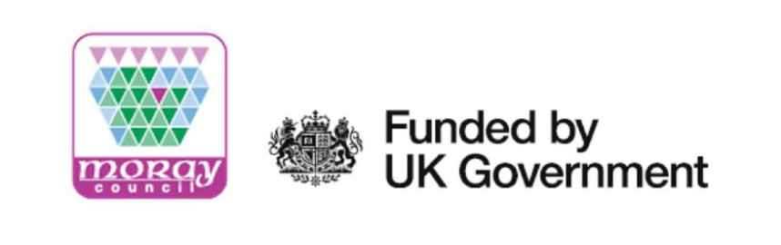

Digital Connectivity - Frequently Asked Questions

- Is my property due to receive better broadband as part of the R100 Programme?

Check your address at Digital Scotland Superfast Broadband to find out if your property is due to receive full fibre installation, and a date to expect this.

- According to R100, I will be getting full-fibre, but not until 2027. Can I speed up this deadline?

If you are on the R100 programme roll-out, and are due to receive full-fibre installation in the coming years, you are not able to speed up this installation, as the R100 contracts have been agreed on a national level with the successful contractors. However, you are eligible to use a £400 voucher to obtain an interim superfast broadband connection now. This could be Fixed Wireless, Satellite or Mobile Broadband, offering you superfast speeds until full-fibre is installed to your property. This voucher must be used by 31st March 2022.

- Who is delivering the installation of full-fibre to my property, and is there a process for complaints?

BT has been awarded the contract for delivering the R100 installations across Scotland. BT’s supply-chain partner Openreach will be the frontline installers of the infrastructure. If you have any concerns or comments that need to be escalated, we recommend you utilise the Enquiries section of the R100 website: Public Enquiry (evolutive.co.uk)

- The Scotland Superfast website address checker states I already have access to superfast broadband speeds, but I am still unhappy with my broadband speeds, what can I do?

Use a broadband speed checker (such as this one). This will show you what speeds you are currently getting at your property. Please note that speeds are affected by number of devices connected to your internet, and what it is being used for at the time, so try to check your speeds at a quiet time, when there are no other devices connected. If at this point you are still not able to receive speeds of 30Mbps or more, contact your current Internet Service Provider, who can check more detail at your connection, and may be able to increase your speeds. If, however, your Internet Service Provider informs you that you are not able to access Superfast speeds, then you can submit an enquiry to R100 to be added into the programme, to obtain a voucher using the enquiry form.

If you do have access to speeds of 30Mbps or greater, then you are not eligible to utilise the Scottish Broadband Voucher Schemes as part of the R100 Programme. However, you may be eligible to receive a voucher from UK Government as part of the Gigabit Broadband Voucher Scheme, helping rural properties obtain gigabit level speeds (>1000Mbps). For more information, please check the Gigabit Voucher website.

- How much will I be paying for internet with Superfast speeds, and can the vouchers be used towards monthly subscription costs for broadband?

The Scottish Broadband Voucher Schemes can only be used for the installation of equipment for a broadband solution (i.e., the router, cabling, any external equipment, and installation costs). For this reason, it cannot be used towards monthly subscriptions. As part of the Voucher Schemes, you will be required to agree to a minimum 12-month contract with the supplier installing your internet solution. The R100 programme follows UK Government’s Universal Service Obligation, and any broadband solution delivering 30Mbps will not exceed £46.10 per month. As with any utilities, it is recommended that you opt for a broadband package that will suit your needs, therefore it is important that you research all options available to you.

- Will the voucher cover all the costs?

Vouchers serve as subsidies towards installation and equipment costs. Installation of Fixed Wireless, Mobile Broadband and Satellite solutions should all be covered by the available vouchers. Full-fibre installations are generally more expensive, and costs may not be fully covered by the voucher. In this instance, there are a couple of options available:

- Your property may also be eligible for the UK Government’s Gigabit Broadband Voucher Scheme, and you can check eligibility for this here. This could provide an additional £1,500 for residential premises, and £3,500 for business premises.
- If your property receives internet download speeds of less than 10Mbps, you may also be eligible for the £3,400 subsidy from Ofcom, as part of the Universal Service Obligation. More information can be found here.
- If you are in close proximity to other premises eligible for the vouchers available, these vouchers can be aggregated, or combined, to increase the spending power to install broadband solutions.

- Will R100 rollout plans / dates change? My property will not be reached with Full-Fibre, can my property be added into the rollout?

The R100 roll-out contracts are unlikely to change, as the contracts have already been agreed and signed by the Scottish Government, and the successful contractor (BT / Openreach). Therefore, properties will not be added in to the R100 full-fibre installation build outs. Any new properties (new builds or change of use) that were not included in the initial R100 surveys, will be made eligible for the Main Voucher Scheme where appropriate. This can be request through the R100 enquiry form.

If your property is eligible for the Main Voucher Scheme, but there are properties around you which are included in full-fibre installation plans, then your property may be connected along with your neighbours during the installation phase. This is not guaranteed however and is at the discretion of the successful contractor (BT / Openreach).

At present, the planned dates of installation are not due to change. As the R100 installations progress, dates will become more specific as locations are surveyed, and implementation plans are submitted for each area. Please see the Scotland Superfast website for any updates.

Types of Broadband available in our Region
Below you will find more information about the four types of Broadband connection available within Moray:

Full Fibre Broadband
- Fibreoptic cables underground direct from the exchange straight to your door
- Capable of delivering Gigabit broadband speeds
- Unlimited data
- Low latency so there is no delay in the connection

Fixed wireless Broadband
- Uses Radio Waves rather than cables
- Capable of Gigabit broadband speeds
- May need a relay aerial setting up closer to your property dependant on the location of the nearest mast – a direct line of sight is required to the property
- Relatively quick and easy to install

Mobile Broadband
• Uses current mobile (4G / 5G) coverage via existing mobile masts
• Quick to set up and install
• Can be used anywhere with a mobile signal
• Low-cost subscription rates
• Reliant on Mobile Coverage

Satellite Broadband
• High speed internet connection using a signal transmitted from space which is then picked up by a satellite on the property
• Available everywhere and not affected by landscape or location
• May suffer connection delays due to distance of the signal to the property from the satellite
• Higher subscription rates

