UKSPF Multiply Small Grant
Guidance and Application Form

Background

Multiply is a ringfenced element of the UK Shared Prosperity Fund with up to £559m targeted across the UK at improving the functional numeracy skills of adults (age 16+) through personal tutoring, digital training, and flexible courses.
The UK Government has identified the following success measures for the programme at a national level:
- More adults achieving maths qualifications / participating in numeracy courses (up to and including SCQF Level 5).
- Improved labour market outcomes e.g. fewer numeracy skills gaps reported by employers, and an increase in the proportion of adults that progress into sustained employment and / or education.
- Increased adult numeracy across the population

Establishing Multiply in Moray

Our goal in Moray is to use this funding to establish and consolidate a ‘numeracy pathway’ which ensures we have a range of support from confidence building through to gaining numeracy related qualifications relevant to work.

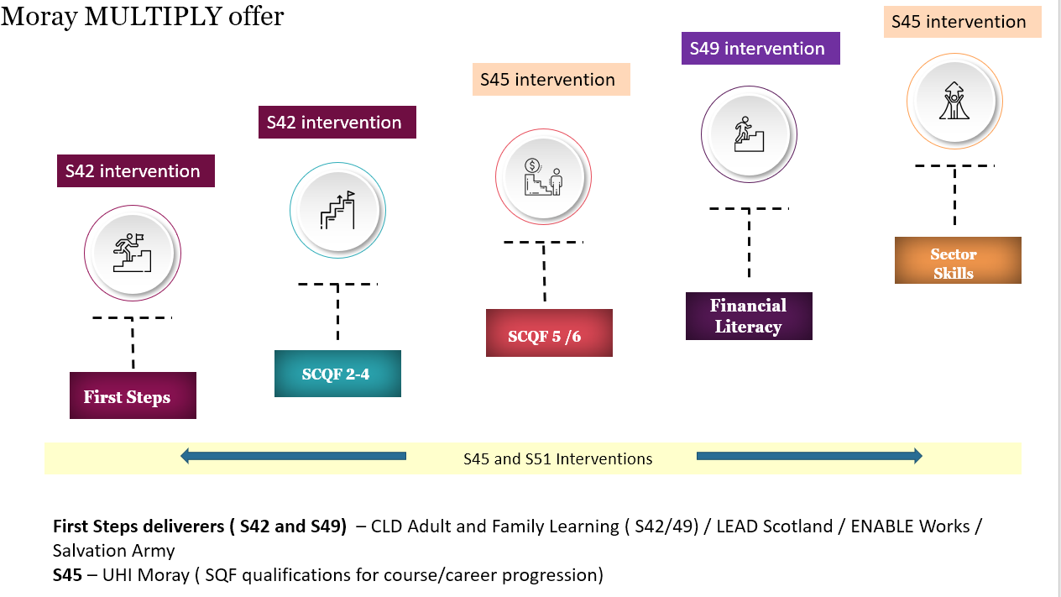

Our target audience is people aged 16+ who are out of work or who are in education or work but are struggling to progress due to numeracy related challenges. The MULTIPLY fund is being managed by the CLD Strategic Partnership with core delivery partners being.

- Moray Council Communities (CLD) – Adult and Family Learning
- Moray College/UHI
- LEAD Scotland (Linking Education and Disability)
- Enable Works
- Salvation Army

Multiply funding in Moray is principally focussed on 2 key interventions:

- S42 - Courses designed to increase confidence with numbers for those needing the first steps towards formal qualifications.
- S49 - Courses designed to help people use numeracy to manage their money.
The Moray Numeracy Pathway also encourages interventions relating to
- S45 - Courses aimed at people who can’t apply for certain jobs because of a lack of numeracy skills and/or to encourage people to upskill to access a certain job or career.
- S51 – Activities, courses or provision developed in partnership with community organisations and other partners aimed at engaging the hardest to reach learners – for example those not in the labour market or others identified locally as in need.
Applications are invited for activity which contribute to either of the lead intervention S42 or S49 – and which may also include elements of S45 and S51. You will be asked to identify the lead intervention under which you are applying as part of your application and will be required to report against outputs for that intervention accordingly.

Multiply Outcomes

You will be asked to estimate the number of beneficiaries you intend to work with in relation to the appropriate Multiply intervention, including whether any of the beneficiaries will gain a maths qualification. We anticipate that many applicants will be focussing on improving confidence with numbers in general and in relation to financial literacy rather than on qualifications.

As part of the funding criteria successful organisations will be encouraged to put at least one person through Numeracy Champions training with National Numeracy – delivered in two three-hour group sessions online.

Funding Package

Multiply funding in Moray will be available for project delivery from April 2024 – March 2025. Grants are available up to a maximum of £25,000 per organisation. There are two ways to cost your project -

Eligible costs can be done one of two ways depending on what best suits your project.

- Staff costs plus 40% oncosts. By this method eligible costs are staff salary plus employer’s NI plus employer’s pension. Then add 40% to cover any additional oncosts associated with the project.

For this method you must supply the following as evidence: payslip; evidence of employers NI and pension; bank statement showing pay; BACS statement (if relevant); job contract; job description; timesheets showing how much time spent on project (if job description says 100% of time to be spend on this project, then timesheets not required)

- Actual costs incurred. For this method you must supply copies of all invoices and their matching bank statements. For any staff costs we would require the same info as in A} above i.e. payslip; employers NI and Pension; bank statement; BACS statement (if relevant); job contract; job description; timesheets.

Timeline

The Multiply grants programme will be launched in March 2024, with a 3-week period to develop and submit applications. An Assessment Panel will meet to review applications and applicants will be notified of the outcome by the end of April 2024.

Date | Action
18^{h} March | Applications open
14th April | Deadline for submission of applications
By 19th April | Assessment Panel Decisions
Delivery | Projects commence within 2 months at most.

Reporting

Successful applicants will be required to complete a monitoring return on a quarterly basis confirming the spend that has been incurred and progress made towards the outputs and outcomes agreed. A template will be provided for this purpose and a final report will be required on completion of the project.

Payment of Multiply Grant

Payment of the grant awarded will be on receipt of the offer of grant acceptance letter.

Submission

To apply for funding please complete and return the application form below to kevin.mcdermott@moray.gov.uk, by the deadline date of 14th April 2024.

How we will score your application

Award/Technical Criteria | Weighting 80%
Previous experience in making adult learning accessible to learners. | 10%
Understanding of your target audience and why your delivery will benefit them. | 40%
Previous experience of accreditation and the SQA Framework and/or the delivery of numeracy related courses levelled against the SVQF framework. | 10%
Strength of your Project Plan | 40%
 | 100%
Pricing Schedule | Weighting 20%
Total Price | 100%

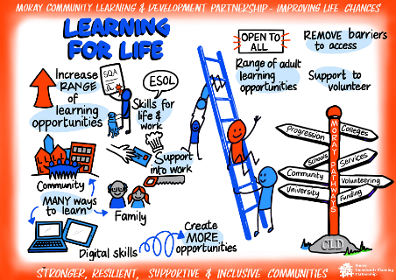
UK Shared Prosperity – Moray

Multiply Grants Fund 2024 - 2025

APPLICATION FORM

Section 1 – Contact details.

Project name
Lead Partner Organisation

Contact Name

Contact Address

Contact Number

Contact Email

Section 2 – Project Information

What is the project aim: what is the problem you are trying to solve using this funding? (approx. 100 words)

Ideally this will be measurable and will include: the problem you are trying to solve, what you hope will be improved; how much of an improvement you hope to see and what timeframe you expect it to be achieved in.

Which lead multiply intervention are you seeking to support (please tick at least one lead intervention):
S42 - Courses designed to increase confidence with numbers for those needing the first steps towards formal qualifications
S49 - Courses designed to help people use numeracy to manage their money.

Which other multiply intervention are you seeking to support
S45 - Courses aimed at people who can’t apply for certain jobs because of a lack of numeracy skills and/or to encourage people to upskill to access a certain job or career
S51 - Activities, courses or provision developed in partnership with community organisations and other partners aimed at engaging the hardest to reach learners – for example those not in the labour market or others identified locally as in need
Please provide a brief project outline (approx. 500 words).
This should include:
• Who this project is aiming to help and why
• What will be delivered: how, where, when and by whom (give details on all partners involved)
• Any risks or challenges anticipated in achieving this – and how you intend to address these
• How the activity will engage with other elements of the employability and/or numeracy pathway in Moray
.

Please provide more detail on the numeracy outcomes the project aims to support and evidence of need. (approx. 250 words) and provide the number of beneficiaries you intend to work with in the table below.

 | Numbers participating in Multiply courses/ sessions (required) | adults achieving maths qualification up to & including SCQF Level 5  (if applicable)
S42: Courses designed to increase confidence with numbers
S49: Courses designed to help people use numeracy to manage their money.
S45: Courses aimed at encouraging people to upskill to access jobs/careers
S51: Provision developed in partnership with community organisations

How will you capture, reflect on, and share the impact of the project and any lesson’s learned? (approx. 150 words)

Please include detail on:
- anticipated number of people you will reach and evidence individual registrations, positive progressions, and anticipated outcomes.
- How you will demonstrate learning and the impact of what you do,
- plans for reflecting on findings and sharing them both internally and with others.

When will your project start and finish?

In which locality(ies) do you intend to be operating?
Buckie ASG Elgin Academy ASG

Elgin High ASG Forres ASG
Keith ASG Lossiemouth ASG

Milne’s ASG Speyside ASG
WXe could link into eg food bank usage, Money Advice Service usage, national reports: IMD; economic & skills profile of Moray in relation to rest of Scotland/UK; ALIS 2020 stats; Seafield could be an example of expressed need;

Dev flexible offer eg online courses level 3&4;
Presume we are continuing to offer only up to SCQF Level 4 and college will be doing level 5 stuff?
X
Moray wide

Section 3 – Budget Outline
Please provide a breakdown of how the funding will be used, including any partner costs. These headings are intended to help you structure your budget, but you can delete or add lines and appropriate headings as required.

There are two options to show your costs – please choose one method only.

- Option A –Only use if you are costing with Staff Costs plus 40%

Staff  (Staff details of each post and costs for the delivery of this project – include salary, NI and pension costs) | Option A - COSTS

Project delivery costs

40% of totals above

TOTAL =staff costs + 40%

Option B – Use if you are Itemising all costs

Staff  (Travel, training, sessional work costs etc.  please add a row for each staff member) | Option B

PROPERTY/VENUE COSTS

(room/venue/equipment hire etc)

SUPPLIES & SERVICES

(training resources, publicity, etc)

OTHER COSTS PLEASE SPECIFY

(events, engagement, research and evaluation)

TOTAL

If you have any match funding for this project, please provide details below?

Section 4 – Certification

To be completed by applicant

I have read and agree to comply with the details of this fund and confirm the information given in this application is correct.

I confirm I have the required authorisation to sign and submit this application on behalf of the applicant organisation.

(Electronic Signature with confirmation email is acceptable)

Name

Job Title

Signature

Date

Section 5 – Application submission

Please send your completed application form and supporting documentation to kevin.mcdermott@moray.gov.uk by the deadline date of 19th April 2024.

