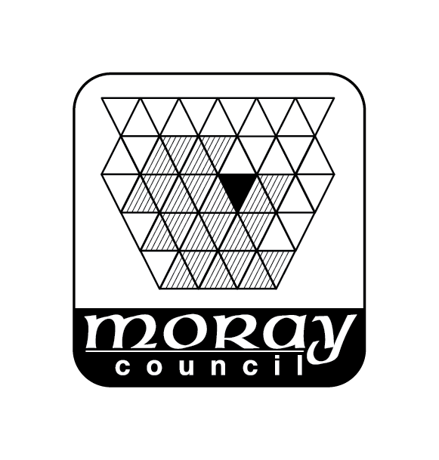
Sports & Leisure Services
Elgin Sports & Community Centre
Activities Timetable 14th August – 7th October 2023

Tel: 01343 543736
Monday to Friday | 8.00am | - | 5.30pm | VIP Childcare
Monday to Friday - Other times available whenever the games hall is free | 12.00noon | - | 1.00pm | Public Badminton*
Mons, Weds & Fri  18th Sept 2023 – 27th March 2024 | 1.00pm | - | 2.30pm | Indoor Bowling
Mondays
Every 2nd Monday from  21st August 2023 | 9.00am | - | 1.00pm | Ukrainian Refugee Resettlement Drop-in information session
 | 9.45am | - | 11.00am | Walking Netball*
 | 11.00am | - | 12.00pm | Baby Massage
Last Mon of the month | 12.30pm | - | 2.30pm | LATNEM meeting
 | 1.30pm | - | 4.00pm | North East Sensory Services
Tuesdays
 | 9.00am | - | 11.00am | Walking Football*
 | 10.00am | - | 11.00am | Active Seniors
Starting 5th Sept – March | 1.45pm | - | 3.45pm | Darby & Joan Club
 | 5.00pm | - | 6.00pm | Elgin Rainbows
 | 6.30pm | - | 8.00pm | 5th New Elgin Brownies
 | 7.00pm | - | 9.00pm | TaeKwon-Do*
Wednesdays
 | 9.30am | - | 1.30pm | Riverside Knitting Club*
 | 10.00am | - | 11.00am | Spinning Class
 | 12noon |  | 1.00pm | Lunch Club
Thursdays
School Term Time only | 9.45am | - | 11.15am | Breastfeeding Support Group
 | 10.00am | - | 11.00am | Active Seniors
 | 11.00am | - | 12noon | Flexercise
 | 7.00pm | - | 9.00pm | TaeKwon-Do *
Fridays
 | 9.30am | - | 3.00pm | Machine Sewing*

* Free entry to Elgin SCC with a Fit Life card (see separate leaflet for further details)

Activity | Cost | Information
Active Seniors | Register with group | Contact: Tracey 07973 149855
Afternoon Bowling | Register with group | Contact: Will Crockett, 01343 545763
Baby Massage | Register with group | Contact: Lorraine McLeod, 07772 601510
Badminton | Current Entry Fee | Adult sessions for all levels
Breastfeeding Support | Register with group | Contact 01343 543736
Elgin Rainbows | Register with group | Vicky Duguid 07825164317
5th New Elgin Brownies | Register with group | Vicky Duguid 07825164317
Darby & Joan Club | Register with group | Seniors Social Club – contact Moira Webb 01343 541001
Escape Pain | Register with group | Rehabilitation class  Contact: Tracey 07973 149855
Flexercise | Register with group | Over 60’s seated exercise class  Contact: Pam Watson 01309 672971
LATNEM | Register with group | Mums peer support group  Website: http://www.latnem.org  Email: latnem@yahoo.com  Facebook: https://www.facebook.com/latnempeersupport
Over 60’s Lunch | All over 60’s welcome | Contact us on 01343 543736 for details
Machine Sewing Group | Current Entry Fee | Friendly group of machine sewing/embroidery – various abilities. Contact: Edith Weatherhead, 01343 550878
North East Sensory Services (NESS) | Register with group | Social activities for sensory impaired adults.  Contact: Heather Roy 0345 2712345  Email: heather.roy@nesensoryservices.org
Riverside Knitting Club | Current Entry Fee | Friendly, welcoming club of hand & machine knitting – various abilities. Contact: Maureen Whyte, 01343 830062
Spinning Class | Register with group | Contact: Tracey Carrington-Hume, 07973 149855
Tae Kwon Do | Register with group | Learn techniques with the opportunity to attend gradings. Contact: John Williamson, 01343 549464
VIP Childcare – Moray | Register with group | All day childcare service for 50 weeks of the year. Contact: 01343 551627
Walking Football | Register with group | All over 50’s welcome
Walking Netball | Register with group | All over 50’s welcome

