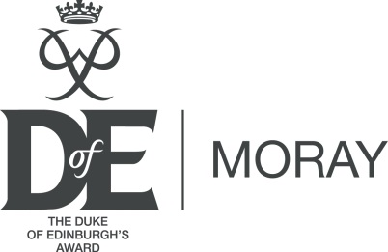

Moray Duke of Edinburgh’s Award Committee Funding Request – Equipment or Project Support

The Moray Duke of Edinburgh’s Award Committee’s (MDEAC) is established to support participation in the Award. The committee provides funding for volunteers towards training costs and has provided a quantity of equipment to Centres to support the Expedition section.
MDEAC also wants to help broaden the appeal of the Award by helping to fund projects that remove barriers to participation for young people. This can be something simple such as subsidising camp site fees or hiring a specialist wheelchair. Or it can be more complex such as part funding an ASN expedition that requires adaptive transport and accommodation.

MDEAC ask Centres to explore other options for funding before they decide on an application.
MDEAC may turn down or only partly fund your request.

Please fully complete the application below:

Your information
Centre
Your Role/Job Title
First name |  | Surname
Address
Town |  | Postcode
Phone (daytime) |  | Mobile
Email

Request details
Project Name
Brief Outline of Request
(A description of the Project and the reasons for this application)
Project Location
Project Dates
(or equipment required by date)
Numbers of Young People Supported
How will this Project Benefit your DofE Group or Participants
Full Cost
Amount Requested
Sources of Additional Funding
(ie PEF, local fund raising, personal contributions)

(
Breakdown of Costs
(Please provide as much detail as possible; please use additional paper if required)

MDEAC or the DofE Office will contact you when your application has been approved

We will ask you to provide feedback of how the Project helped support your DofE group and its participants. This helps us to promote the scheme and enables MDEAC to provide evidence that this fund is making a significant impact in improving the experience of DofE participants.

If you have any queries please contact DofE office on 01343 813614 or dofemoray@moray.gov.uk

Please return completed forms to: Funding Application
The Duke of Edinburgh Award
Lossiemouth Community Centre
Coulardbank Road
Moray
IV31 6JW
Email: dofemoray@moray.gov.uk

For office use:
Supporting statement from DofE Office
First name |  | Surname
Comments

