THIS PLAN MUST NOT BE CHANGED/ADAPTED/AMENDED UNDER ANY CIRCUMSTANCES. If you have recommendations for change, please contact Lynne.Riddoch@moray.gov.uk

Check boxes below to highlight sections completed

If making a Request for Assistance, sections 2, 3 and 4 must be completed and submitted with section 1.

Following the Moray GIRFEC Pathway will support you in making decisions about what services to involve and at what stage. http://www.moray.gov.uk/downloads/file106591.pdf

Section 1  Child’s Details  ☐ | Section 2  Record of Concern/Discussion or Meeting  ☐ | Section 3  Action Plan  ☐ | Section 4  Chronology  ☐

Other documents can be attached as supporting evidence e.g. Learning Support Profile, Young Carer’s Statement, Anticipatory Care Plan, Individualised Education Plan, Co-ordinated Support Plan etc. All of these documents can be found at http://www.moray.gov.uk/moray_standard/page_102559.html

Section 1 - Child Details
Name : | Insert full name |  | Known as : |  | Insert what the child is known as if different
DoB/EDD : | Insert date of birth/estimated delivery date |  | Gender : |  | Insert gender if known
Home address : | Click here to enter text. |  | Telephone No : |  | Click here to enter text.
This is the address of the primary care giver when the child resided at home |  |  | Mobile No : |  | Click here to enter text.
 |  |  | Non-disclosure of address : |  | YES ☐ | NO ☐ C
 |  |  | Reason : Insert details
Current address (if different) : |  | Click here to enter text.
Insert current address of the child
Health Number (CHI) :  (if known) |  | Insert if known |  | Education Number :  (SQA No) | Insert if known
Nursery / School / FE attend : |  | Insert education details
Any conditions/disabilities? |  | Please only note conditions/disabilities that have been formally diagnosed

People important in the child’s life
Name | DoB (if known) | Relationship | Address | Telephone Number | Email Address
Insert name of household members and others with a relationship with the child e.g. parents, step parents, siblings, grandparents, close family friends who regularly spend time with the child/young person  The child/young person should be asked who they believe are the people important in their lives. | Insert date of birth | Insert the nature of their relationship with the child/young person | Insert if known | Insert if known | Insert if known

GP
Name of GP : | Insert details if known
Contact details : | Click here to enter text.

ALL boxes must be ticked
Current Legal Position
Are there any legal orders in place – e.g. compulsory supervision? | YES ☐ | NO ☐ | Previously ☐
Details: Click here to enter text.
Dates (if available): Click here to enter text.
Are there any conditions attached to the order? | YES ☐ | NO ☐
Details: Click here to enter text.
Is the Child on the Child Protection Register? | YES ☐ | NO ☐ | Previously ☐
Reason? Click here to enter text.
Dates (if available): Click here to enter text.
Is the child/young person Looked After? | YES ☐ | NO ☐ | Previously ☐
Home/Kinship etc. Click here to enter text.
Dates (if available): Click here to enter text.
Does the child have caring responsibilities? | YES ☐ | NO ☐ | Don’t know ☐
Does the child have a Carers Statement in place? | YES ☐ | NO ☐ | Don’t know ☐
Details: Click here to enter text.

This section should clearly outline the reasons for requesting assistance to address the child/young person’s needs in relation to the wellbeing indicators. Please check all wellbeing indicators which are relevant to the child’s wellbeing.

SAFE  ☐ | HEALTHY ☐ | ACHIEVING  ☐ | NURTURED  ☐ | ACTIVE ☐ | RESPONSIBLE  ☐ | RESPECTED ☐ | INCLUDED ☐

Completed by (name and role) :
This will be completed by the agreed Lead Professional
Date :
Enter date request for assistance was submitted
Summary of Analysis and Assessment of Sections 2, 3 & 4
Evidence based analysis of assessment findings using My World Triangle and Resilience Matrix appropriate to needs.

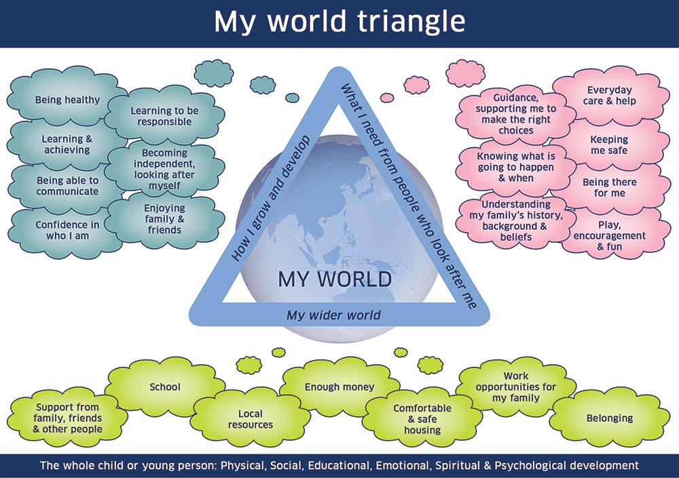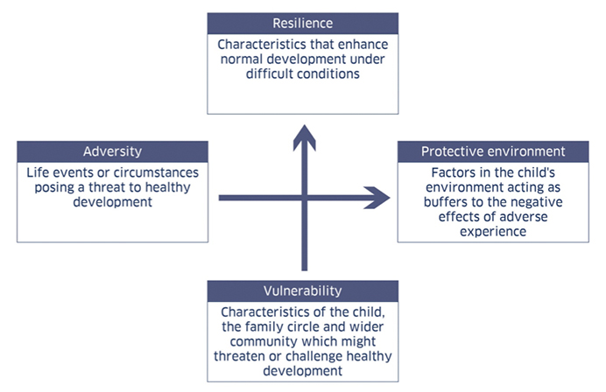

Good quality analysis should help everyone to understand the precise nature of any risks and the exact scope and scale of these as well as any strengths and protective factors. It is essential to record how adversities and vulnerabilities are impacting on the child’s life. Analysis should also identify whether the situation is stable or changing, and whether or not there may be potential for improvement.

Practitioners should consider what the evidence they have gathered means for the individual child/young person including:

- Clarifying the balance between the strengths and pressures in the child’s life
- Evaluating the impact of the child’s current situation on their wellbeing
- Articulating immediate or emerging risks to the child
- Highlighting any differences in understanding the child’s needs

All the information can be provided as bullet points.

Request the service(s) of :
1.
2. More than one service can be requested. Number the service and ensure the number correlates with ‘reasons for request’ and ‘Desired outcome(s)’

To add additional boxes click on ‘Layout’ tab at top of screen and press ‘Insert Below’
Reason(s) for request :
- Insert reason(s) for requesting Service 1
- Insert reason(s) for requesting service 2 etc.
Desired outcome :
1.
2.
- Consider what each desired outcome is and why this outcome is relevant to the child/young person? This should be based on your analysis of wellbeing
- The desired outcome should be realistic, achievable, relevant and proportionate
- It should be a positive statement of change e.g. increased knowledge and understanding, development of a new skill, behavioural change, attitude change etc.
- Where possible the desired outcome should build upon strategies that have been successfully used to achieve goals/outcomes in the past
- Consideration to the timeline of this support should be given

I agree with the above Request for Assistance.
Child : | Click here to enter text. | Date : | Click here to enter text.

I agree with the above Request for Assistance.
Parent / Carer : | Click here to enter text. | Date : | Click here to enter text.

Section 2 - Child’s Name (DoB) - PLAN

Section 2 is an analysis of the child’s wellbeing. The first step is to undertake an assessment to establish areas of need, risk, resilience and strength. This can be undertaken through discussion with the child, family and professionals or via a formal meeting. If it is being used as a Record of Concern, the child’s and family’s views MUST also be noted before submission to other professionals.

The Privacy Statement must be discussed, shared and agreed at the start of the planning process. This can be found at http://www.moray.gov.uk/moray_standard/page_102559.html
Please be familiar with the ‘Practitioners Guide to Information Sharing’ which can be found on the GIRFEC website. This will be helpful in regard to when consent to share information is needed. http://www.moray.gov.uk/moray_standard/page_80430.html

Looked After Child Reviews and Child Protection Case Conferences are Social Work led reviews of a child or young person’s wellbeing. They take place in the Looked After and Child Protection frameworks. The minutes and associated action plans from these meetings (including Core Group Meetings) are not recorded in this format but should be saved in the child or young person’s file for reference.

Record of Child Planning (Analysis of Wellbeing: Discussion or Meeting or Record of Concerns)

Child’s Name : Click here to enter text.
Date : Click here to enter a date.
Named Person : Click here to enter text. | Referrer : Click here to enter text.  If the referrer is different to the Named Person, the referrer should take the lead with gathering the information for this section either by gathering the information via telephone, e-mail etc. or organising a meeting for the information to be gathered.
Present (If Applicable): | Role and Agency:
- Child and Parent(s)/Carer(s) must be noted first
- Names of all professionals involved in plan

Apologies (If Applicable): | Role and Agency:
- Child and Parent/Carer must be noted first
- Names of all professionals involved in plan
- No apologies received should also be noted and clearly marked as ‘no apologies received’

Why does this child need a plan? PURPOSE of the plan
- This is the over-arching goal of the process, which will be broken down in to smaller manageable goals through the solution oriented process.
- Typically these statements will indicate a move towards the intended outcomes rather than a forced end point and would start with phrases such as:
- ‘Finding ways to support x and their family in…’
- ‘Exploring ways forward to increase x’s engagement in school and relationships with peers’.
- Ideally the purpose will be stated in invites and checked for consensus at the beginning of the meeting

Section 2 can be used by any agency at single agency level.

Single Agency ☐ | Multi Agency ☐
Chairperson (If Applicable):  Click here to enter text. | Scribe (If Applicable):  Click here to enter text.

If it is a multi-agency meeting, the professional chairing the meeting MUST be different to the person scribing. Agreement about who will take on each role should be agreed prior to the meeting. Only under exceptional circumstances should it be the same professional chairing and scribing.

A clear explanation of the process and the parameters of the meeting must be explained to all. Pre conversations may be required to support participant engagement and supports offered as appropriate. It is important chairs are trained in Solution Oriented Meetings. ‘Moray Meeting Guidance’ can be accessed at http://www.moray.gov.uk/downloads/file111796.pdf It gives useful and practical guidance on how to run Solution Orientated meetings. Training is regularly available in Moray via Gateway and the MLDG calendar.

In planning for the child or young person consideration must be given to all the wellbeing indicators https://www.gov.scot/policies/girfec/wellbeing-indicators-shanarri/
All partners, including child and family, should discuss strengths and concerns relating to the wellbeing indicators.

Consideration must be given to each Wellbeing Indicator
SAFE | HEALTHY | ACHIEVING | NURTURED | ACTIVE | RESPONSIBLE | RESPECTED | INCLUDED

Each entry should:
- If possible or appropriate indicate how the child/young person feels in relation to each of the wellbeing indicators;
- Consider both the strengths and concerns;
- Include strategies that have been used and the extent to which they have been successful and why;
- Proportionately consider the Resilience Matrix and My World Triangle.
Some areas can be pre-populated prior to a meeting e.g. child’s views.
Issues/concerns? So what?  (Risks)  These views are made as statements and not deconstructed or discussed.  As far as possible own words /not challenged | What’s going well? So what?  (Strengths/ Protective factors)  This section can help build the sense of competency in participants and factors that are going well will be worth exploring.  Key questions include:  ‘How did you manage that?’  ‘What did you do differently?’  ‘What did others do differently?’  ’Who noticed this change?’
Child’s Views
- Article 12: I have the right to be listened to, and taken seriously. Article 12 of the UNCRC says that children and young people have the human right to have opinions and for these opinions to matter. It says that the opinions of children and young people should be considered when people make decisions about things that involve them, and they shouldn’t be dismissed out of hand on the grounds of age. It also says children and young people should be given the information they need to make good decisions.  - Information about advocacy must be provided prior to any meeting  - There are various tools that can be used to gather the views of the child or young person prior to the meeting (APPENDIX/LINK – still to be added).  - Discuss with the child:  Do they want to submit their views prior to the meeting? (oral/written?)  Do they want to be present at the meeting?  Where do they want to sit if they attend?  Who do they want to sit beside?  - Please note their views in own words as far as possible. Children can contribute from a very young age and should always be given the opportunity to contribute; however they can equally refuse to give their opinion and shouldn’t be pressured to do so. Please note clearly if they refuse to engage. | Article 12:  1. States Parties shall assure to the child who is capable of forming his or her own views the right to express those views freely in all matters affecting the child, the views of the child being given due weight in accordance with the age and maturity of the child.  2. For this purpose, the child shall in particular be provided the opportunity to be heard in any judicial and administrative proceedings affecting the child, either directly, or through a representative or an appropriate body, in a manner consistent with the procedural rules of national law.
Family/Carers/Parent’s Views
- Information about advocacy provided
- Family/Carer’s/Parent’s views should, as far as possible, be noted in their own words.
- This can be done prior to a meeting if one is being held.
Professional Views
- Professional’s views can be submitted prior to the meeting, especially if they can’t attend.

Ideas Box
- The ideas box has been provided so possible actions/solutions can be noted throughout the meeting.
- It will provide small manageable targets and feed directly in to the plan in part 3.
- This will support in forming a robust Action Plan. (See Section 3)

Section 3 - Child’s Name (DoB) - ACTION PLAN
e.g. JOHN SMITH’S ACTION PLAN

What is Needed to Support this Child and their Family?

An Action Plan is designed to address the child or young person’s needs in relation to identified wellbeing indicators. Tick the boxes to highlight the main concerns regarding the child or young person’s wellbeing. Please ‘check’ all wellbeing indicators which are relevant.

Please Indicate Concern
SAFE ☐ | HEALTHY ☐ | ACHIEVING ☐ | NURTURED ☐ | ACTIVE ☐ | RESPONSIBLE ☐ | RESPECTED ☐ | INCLUDED ☐

Wellbeing Indicator | Outcome identified with the child/ family | What needs to happen?  (action) | How will we know it has been achieved?  (measuring progress) | When? | Who? | Action completed  Yes/No/Partial  include date
Insert relevant wellbeing indicator | What are the desired outcomes based on your analysis of wellbeing and why is the outcome relevant to the child or young person? What is the purpose?  An outcome is something that we are trying to achieve in the long term. | - Take each outcome in turn and consider the actions, including targeted interventions, which could support the longer term outcomes.  - Insert particular strategies and locations that will be used to support the child/young person.  - Some outcomes will need only one action; others will be more complex and require a series of actions to gradually build up to the longer term outcomes.  - Always begin with the actions the child or young person is going to undertake, followed by the family, and finally the targeted interventions/actions being supported by the professional | Insert how you know will know the target has been achieved or successfully moved the situation forward:  - What is the measure of success?  - What will indicate progress has been made?  - Choose methods of measurement e.g. agency specific assessments, self-reports, observations, wellbeing web, reduced exclusions, % increase in attendance, feedback from partners, standardised assessment, meeting developmental milestones including weight and height  - Hard/soft indicators should be used.  - hard indicator may be reduced number of violent incidents in class  - soft indicator may be that the child/young person reports they feel happier and settled  These measures are best agreed with the child/young person and their family and should measure the impact of the intervention on the desired outcome, not the effort of the partners | By when? Dates must be included to ensure progress is measurable | Who will support this target? Names and Services need to be detailed to allow all involved to be clear about who is responsible for what and when in supporting the child. | Insert yes, no or partial when you review the plan
Rows can be added/deleted as necessary. To add additional boxes click on ‘Layout’ tab at top of screen and press ‘Insert Below’

Child’s views of the plan
Comment : What does the child/young person think of the plan? Do they think it will help them? This should be a brief factual statement of how the child feels about the support defined in the plan.

As far as possible note the views of the child or young person using their words. This can be done during or after the meeting. All efforts should be made to articulate their views even when there are communication difficulties. There must always be text in this box.

It is imperative that the child’s disagreement with the plan is noted here.
Information about advocacy offered to child/young person/family | Y ☐ | N ☐
Advocacy can be anyone who the family, child or young person wants to support then in the meeting. It does not have to be an organisation such as Children 1st or Who Carers. However, an offer of support should always be made.

Parent / Carer views of the plan
Comment : What does the parent/carers think of the plan? Do they think it will help them? This should be a brief factual statement of how parents/carers feels about the support defined in the plan.

As far as possible note the views of the parents/carers using their words. This can be done during or after the meeting. All efforts should be made to articulate their views even when there are communication difficulties. There must always be text in this box.

It is important that any disagreement with the plan is noted here. This should be the exception as we must as far as possible try to work in partnership with the family and agree actions that meets the needs of the child and their family.

Who is Lead Professional? Please include name and role
A Lead Professional must be identified. It should be agreed prior to the meeting who is best placed to be Lead Professional. The family must be consulted at the meeting and agree before it is finalised. At future reviews it MUST be checked that the identified Lead Professional is best placed to co-ordinate the Child Planning Process.

LEAD PROFESSIONAL: The role of the Lead Professional must be undertaken by an individual who has the background, experience and position to ensure that the Child’s Plan is managed and co-ordinated effectively.

Who can be the Lead Professional?:
- The Lead Professional is suitably trained and experienced to fulfil their role in line with other statutory requirements and local guidance
- There is a clear link between the role of the Named Person and the Lead Professional and a system to support appropriate collaboration

Any disagreements?

Date/Time/Venue of Next Review : | Date Child’s Plan Closed : | Reason :
This should happen within 12 weeks of opening the child’s plan, thereafter as often as deemed necessary taking into account the child/young person’s individual situation to adhere to legal timescales for review. Single agency plans should be reviewed in line with established procedures and at a time appropriate to the child/young person’s needs. | Click here to enter text. | Click here to enter text.

REVIEW OF CHILD’S PLAN

A review considers everyone’s point of view and will inform future practice. It examines how appropriate the interventions have been in meeting the child/young person’s individual need and to what extent the desired outcome has been moved on. Ideally all partners will be present at the time of review but where this is not possible, opinions and thoughts should be gathered and used to inform the process.

If progress is deemed unsatisfactory:
- the time scale and/or approach should be readdressed, reformed and recorded along with any updated information and/or further advice
- If an approach/resource hasn’t worked it must be changed rather than the timescale extended
- Failure to make progress towards achieving an outcome should trigger an early review of the plan which should include the chronology.
Section 4 - Child’s Name CHRONOLOGY
e.g. JOHN SMITH’S CHRONOLOGY

CHRONOLOGIES can be a valuable tool in identifying patterns and emerging risk and concern to children, young people and their families. It is a critical tool in helping make sense of the complexity of a child’s and family’s life and circumstances. It can establish a sound base for future understandings, and analysis where professional staff change, or new staff or services come on board.

Chronologies should provide an easily assessable summary of information to help in discussions with practitioners, children and their families around any wellbeing concerns.

In Universal Services, Health can provide a copy of their single agency chronology and Education can provide a copy of significant events from SEEMiS for their single-agency chronology.
Below is a multi-agency chronology of significant events in the child’s life that are relevant to support the current multi-agency involvement in a child’s life. The information is taken from the single agency chronologies. Professional judgement is required to decide what needs to be included. All information that is included must be proportionate and appropriate.

FAMILY / INDIVIDUAL
Source – H = health, E = education, P = police, SW = social work, F = family, O = other (please detail)

Date of Event | Age of Child | Detail of Significant Event | Outcome | Source
The date the event occurred should be recorded here | Insert if known | - A brief description of the event should be recorded here.  - Children, young people and families will see this information.  - Language should be in plain English, non-judgemental, clear and concise so that the chronology improves understanding and supports good decision making.  - A significant event is: Any event, and/or concern, which has a significantly positive or negative impact on the child or young person. It is NOT a record of an agency’s involvement with a child/young person.  - An historical event may not be significant at the time Professional Judgement  - It does not have to happen to the child but may be a change in circumstances which has a positive or negative effect on their wellbeing.  - Interventions that have impacted positively or negatively. | - Each significant event and/or intervention will have an impact on the child or young person’s wellbeing and from that, will be determined the outcome.  - Where this is clear and/or known, this should be recorded.  - Outcomes may also be positive and/or negative. | Information in the chronology should be current, factual and from a reliable source.  Record where the information about the significant event has come from.
 |  |  |  | Please tab from here to create a new row

The Lead Professional will maintain the integrated chronology in collaboration with the Team Around the Child. (TAC)

For further information go to:
http://www.moray.gov.uk/downloads/file112599.pdf
http://www.careinspectorate.com/images/documents/3670/Practice%20guide%20to%20chronologies%202017.pdf

