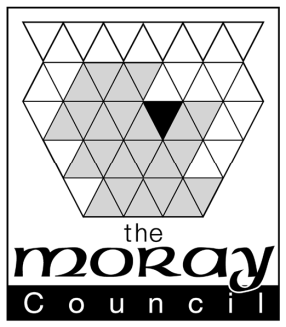
Notification of Occasional Use Cinema Event
This form must be submitted to licensing@moray.gov.uk at least 7 working days before the event
Name and address of Venue:……………………………………………………………………..
………………………………………………………………………………………………………..
Date(s) and time(s) of event:
…………………………………………. ………………………………………….……………………
………………………………………………………………………….…..........................................
Description of event:
…………………………………………………………………………………………………………..
…………………………………………………………………………………………………………..
…………………………………………………………………………………………………………..
Expected Attendees…………………………………………………………………………………..
Please confirm that you have correct permissions to show a copyrighted film YES / NO
Information available here: http://www.themplc.co.uk/

Please confirm who you received the permission from ……………………………………………
……………………………………………………………………………………………………………
Where applicable, are you restricting access based on the film’s age classification?
………………………………………………………………………………………………………….
Contact Name:……………………………………………………………………..............................
Contact e:mail:………………………………………………………………………………………….
Contact Phone Number……………………………………………………………………………….

The information on this form will be passed to Moray Council Licensing Standards Officers for inclusion in the Events Inspection Visit schedule.

