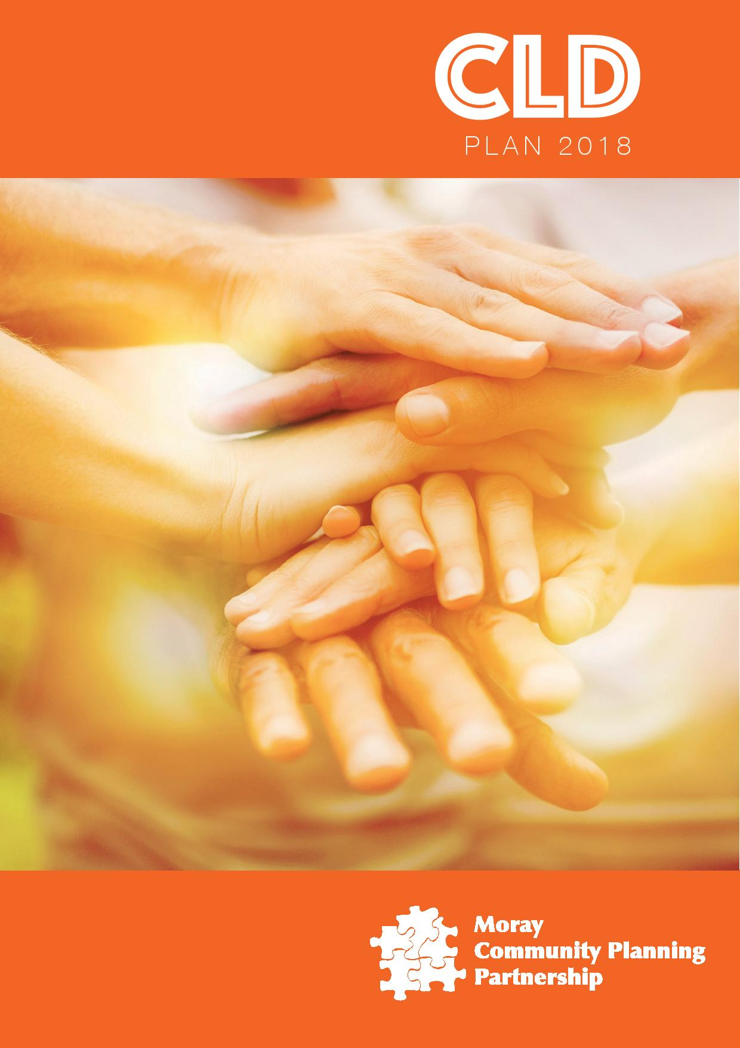

**Contents**

**Section 1**

**Welcome** Page 3

**Section 2**

**CLD Activities** Page 4

*What is Community Learning & Development?* Page 5

*Policy Goals within CLD Regulations* Page 6

**Section 3**

**CLD Governance** Page 7

*Staff, Networks & Communities* Page 7

*Looking Back*  Page 7

*Moving Forward* Page 8

*Getting It Right For CLD in Moray* Page 9

**Section 4**

**Resource Context**  Page 10

**Section 5**

**Moray Local Outcomes Improvements Plan Priorities** Page 11

**Section 6**

**Unmet Needs** Page 12

**Section 7**

**Partnership Strategic Targets** Page13

**Appendices**

**1 – Membership**Page 19

**2 - Glossary of Terms** Page 20

**3 – CLD Outcomes** Page 22

**Community Learning and Development Plan 2018-2021**



**Introduction from the Chair of the Community Planning Board**

Welcome!

I am delighted to introduce the new Community Learning and Development Plan for Moray for the next 3 years as Chair of the Community Planning Board.

As a Councillor I am privileged to be invited to see a huge range of activity that is happening in our communities from learner award celebrations, youth events to community projects, festivals and galas. All of these are about improving opportunities either for individuals and families or celebrating the skills in communities to develop initiatives that make people rally round to make a difference.

It is well documented how challenging the public purse is, however initiatives like participatory budgeting and community asset transfers are encouraging people to stand up and develop provision at the heart of communities that meet needs.

We all have a role to play in community learning and development, from participating in consultations, speaking out about matters of concern, sharing ideas about improving opportunities or volunteering to ensure communities are vibrant and learners thrive. Moray has a strong volunteering ethos and it is no surprise to me that 4 organisations received the Queens Award for volunteering this year, a fantastic achievement.

For whatever reason you come to read this plan, I encourage you to get involved, make contact with officers and make a difference. In Moray let every person and community count.

Sincerely

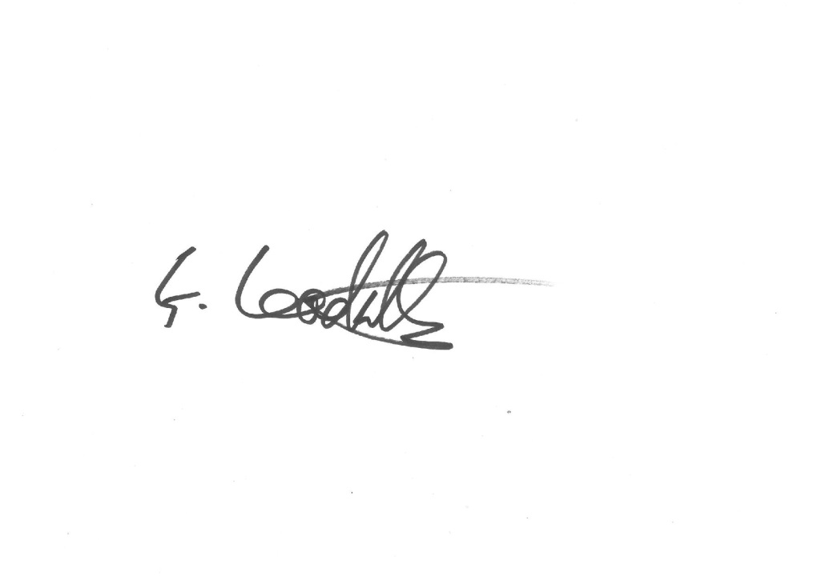

Chair of Community Planning Board

cid:image002.png@01D4346F.CADB2240

**CLD Activities Include:**

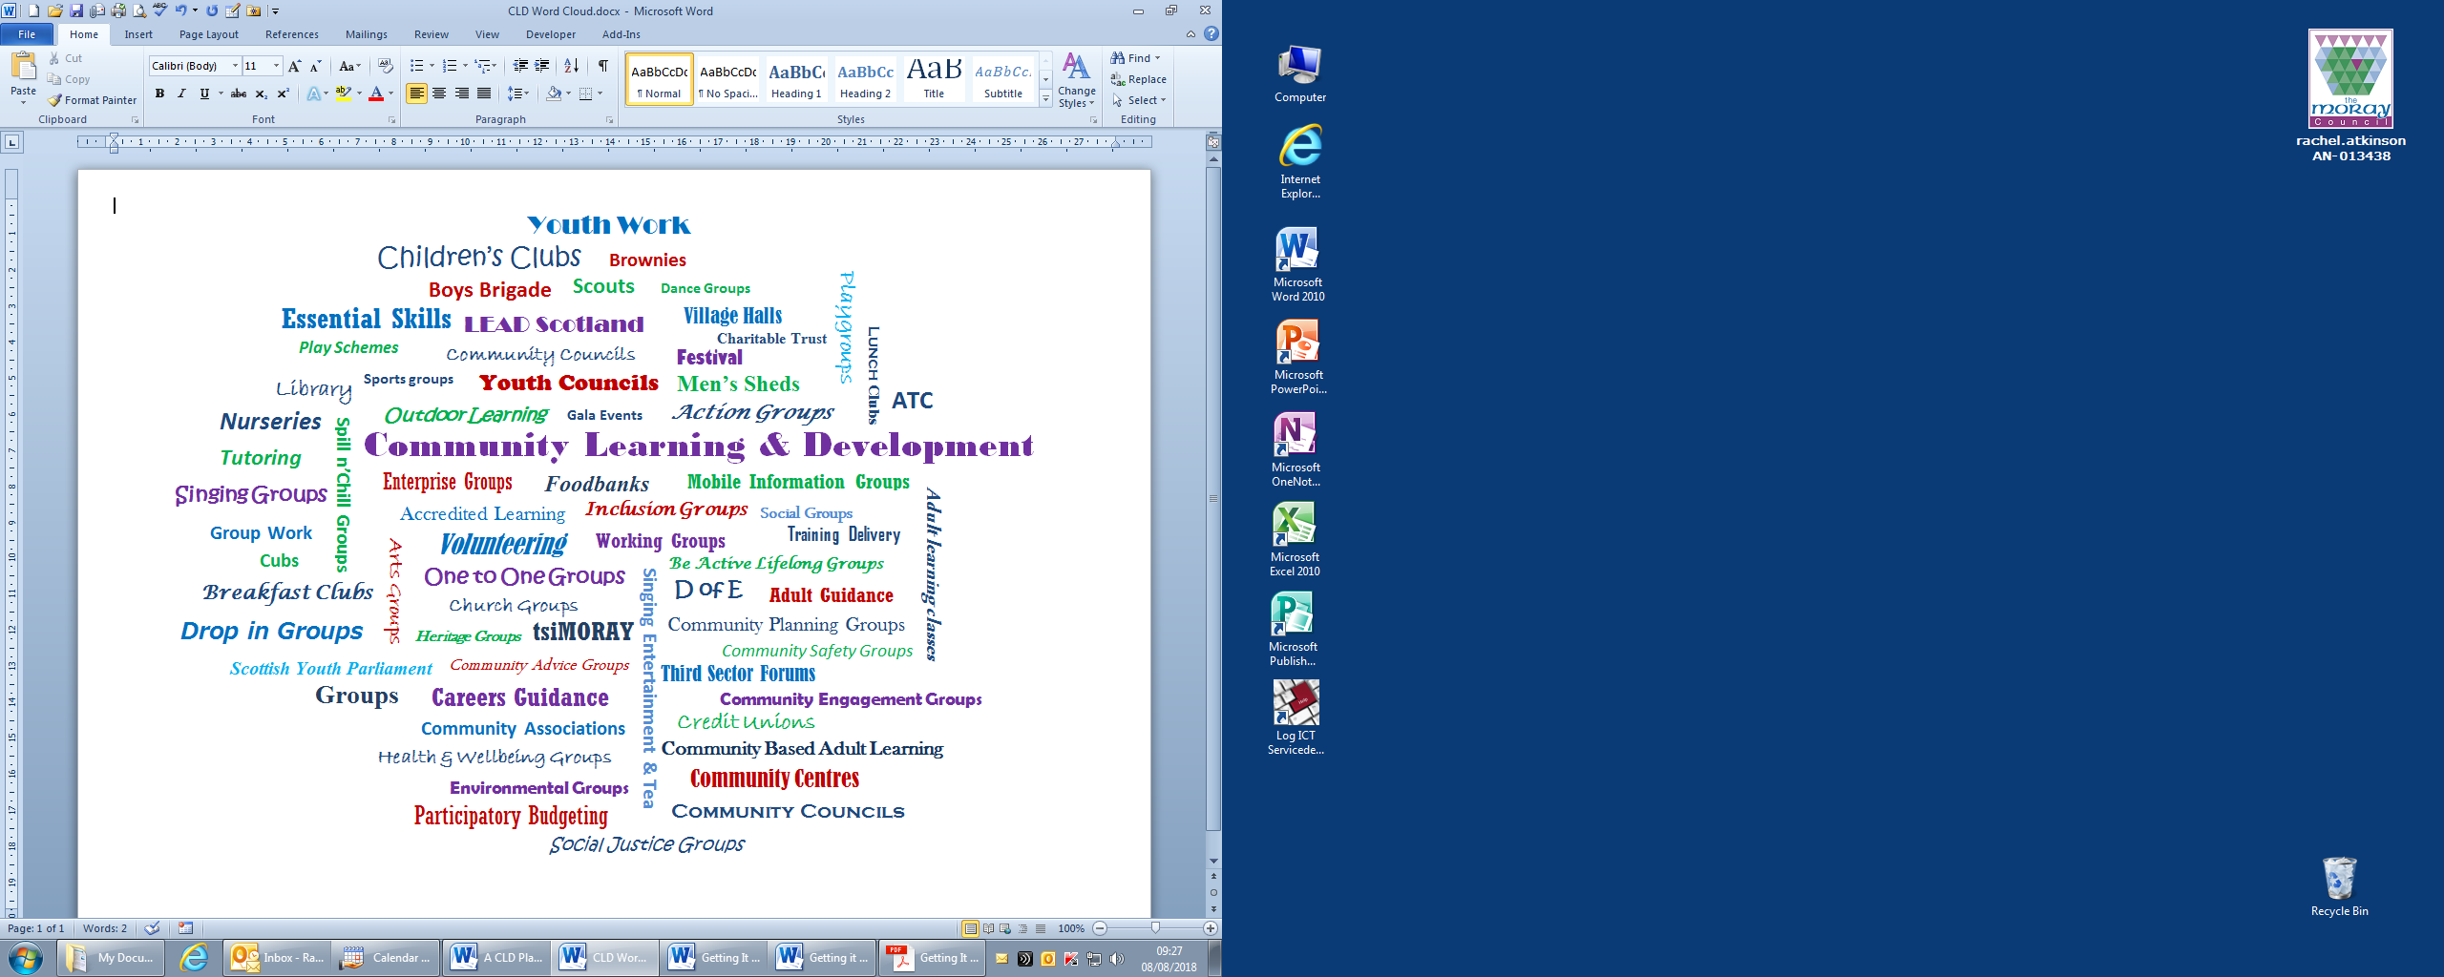



**Duke of Edinburgh Expedition at Lochnagar – 2017**

**So what is Community Learning & Development and why do we need a plan?**

Community Learning and Development (CLD) is delivered in diverse settings across Moray by a wide range of organisations and services including the Third Sector. Whilst some community groups may not appreciate that what they are actually engaged in falls under the heading of CLD activity, larger organisations and services should recognise that the work links to a set of distinct values, attitudes and competences:

<http://cldstandardscouncil.org.uk/resources/the-competences/>

The Scottish Governments aspiration is that **“CLD should empower people, individually and collectively, to make positive changes in their lives and their communities through learning.”**

Guidance was issued to Community Planning Partners in 2012 to oversee developments; however it was down to the local authorities to ***“provide clear leadership and direction, and to drive the action needed to ensure we maximise the contribution of CLD partners in the reform of public services.”***

The requirements for Community Learning and Development (Scotland) Regulations 2013 place a legal requirement on local authorities to take this role forward and require the publication of a plan every 3 years. This direction sits amongst significant legislation and policy expectations which all impact on service providers and communities. We now also have the Fairer Scotland Duty 2018 to comply with:

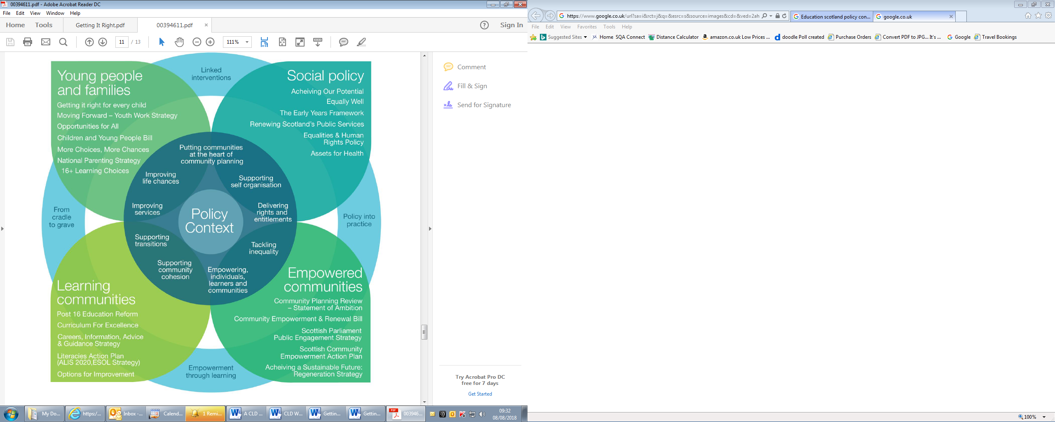

Acknowledgement: Education Scotland

**The following policy goals are within the CLD Regulations:**

* **To strengthen co-ordination between the full range of CLD providers, ensuring that Community Planning Partnerships, Local Authorities and other providers of public services respond appropriately to the expectations set by the CLD Strategic Guidance**
* **To reinforce the role of communities and learners in the assessment, planning and evaluation process, enabling them to shape CLD provision**
* **To make the role and contribution of CLD more visible**
* **To ensure communities across Scotland, particularly those that are disadvantaged have access to the CLD support they need**

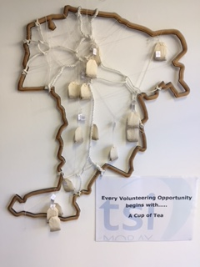

***“Every Volunteering Opportunity begins with…***

***A Cup of Tea”***

Glasgow School of Art Partnership Project 2017 - **tsi MORAY**

**Community Learning & Development Governance**

This plan builds on the learning from the previous 3 years but core to this was the need to revise the governance arrangements to comply with legislative requirements.

In January 2018 Education Scotland inspectors visited Moray for a strategic and place-based inspection in the Buckie ASG area and delivered a report with the following improvement targets:

• **Improve leadership, governance and planning for change at all levels in line with legislative requirements**

**• Improve approaches to the management of risks and meeting CLD standards**

**• Improve the systematic gathering, analysis and sharing of performance information across partners**

Strategically Moray was evaluated as WEAK. The CLD Strategic Partnership had already started work to address the issues and the report confirmed what was known. The Partnership agreed that they would adopt the national CLD priorities as their focus:

1. **Improved life chances for people of all ages through learning, personal development and active citizenship; and**
2. **Stronger, more resilient, supportive, influential and inclusive communities.**

The proposed Governance Structure will be discussed in September 2018 with a named officer strategically with reporting responsibility:

**Community Activists & Learners input to staff**

**CLD Strategic Partnership**

**Community Planning Officers Group**

**Community Planning Board**

**Staff teams, Networks & Communities**

A new Terms of Reference was agreed by partners in July 2018 to take forward our CLD Strategic Partnership including business accountability which has been shared with the Community Planning Officers Group and Education Scotland staff. Information will in future be accessible through the new **tsi**MORAY website and the **Your Moray Community Planning** website so there will be transparency.

**Looking Back…**

In the first CLD Plan 2015-2018 the intention was to develop locality plans and learning partnerships in each associated schools group area but it was quickly evident that this was not sustainable because of restructuring and the prioritisation of resources to early intervention. There is not a CLD Service in this authority to progress actions, so Moray is reliant on good partnership working to take forward a community learning and development approach to deliver services. Consequently the CLD outcomes as detailed in Appendix 3 may be interpreted differently depending on who delivers the provision and their motives of engagement. The original CLD Plan was not owned by the partnership therefore the need to start afresh, albeit with significant work achieved by different partners, was recognised. A CLD Strategic Partnership final review of the first plan will take place in October 2018. In the interim the Education Scotland inspection of the Buckie area in 2018 affirmed key strengths:

* Strong partnership between Buckie High School, youth workers and other partners that is enriching the learning offer for young people; and a
* Strong culture of volunteering and effective community groups contributing to a strong sense of place

**The provision was evaluated as Good.** As a partnership we need to ensure that the learning offers are well signposted and consistent in each associated schools group, that between school and community all learners feel included and have a range of accessible opportunities and experiences to enable them to aspire.

**Moving Forward…**

This new plan focusses on reinvigorating the strategic group, their terms of reference and partnership work plus 5 themed improvement areas developed with local people:



**People**: Improving the learning offer across communities



**Place:** Making the most of assets and opportunities in communities



**Prospects:** Ensuring the CLD workforce is skilled, with access to opportunities and accreditation, and succession planning is embedded



**Publicity:** Improving understanding of CLD through better publicity, networking and information sharing



**Strategic:** Ensuring robust scrutiny and accountability through transparent reporting processes

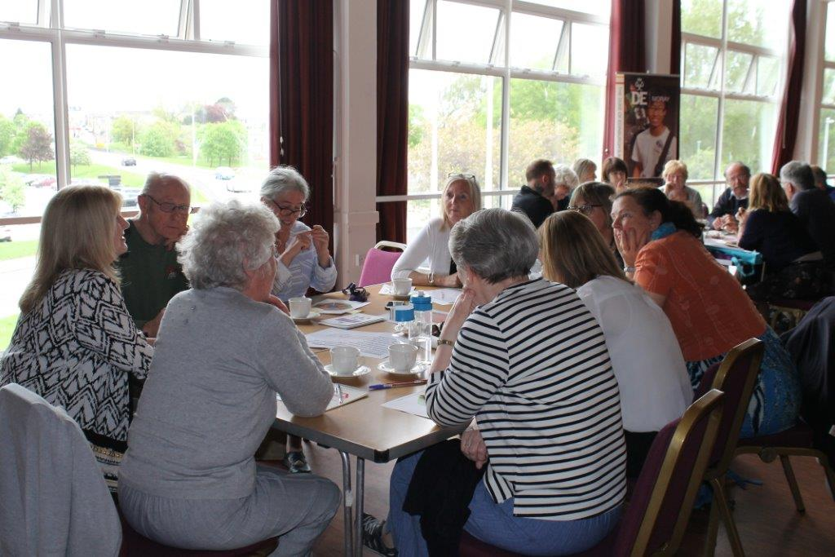

**“CLD - A Road to Travel”**

15th May 2018

|  |  |  |  |  |  |  |  |  |
| --- | --- | --- | --- | --- | --- | --- | --- | --- |
|  | | | | | | | | **LOIP Themes** |
|  | | | | | | | | **Local People’s CLD Themes** |
|  |  |  |  |  |  |  |  | **GIRFEC Themes** |

**Getting It Right for Community Learning & Development**

**in Moray**

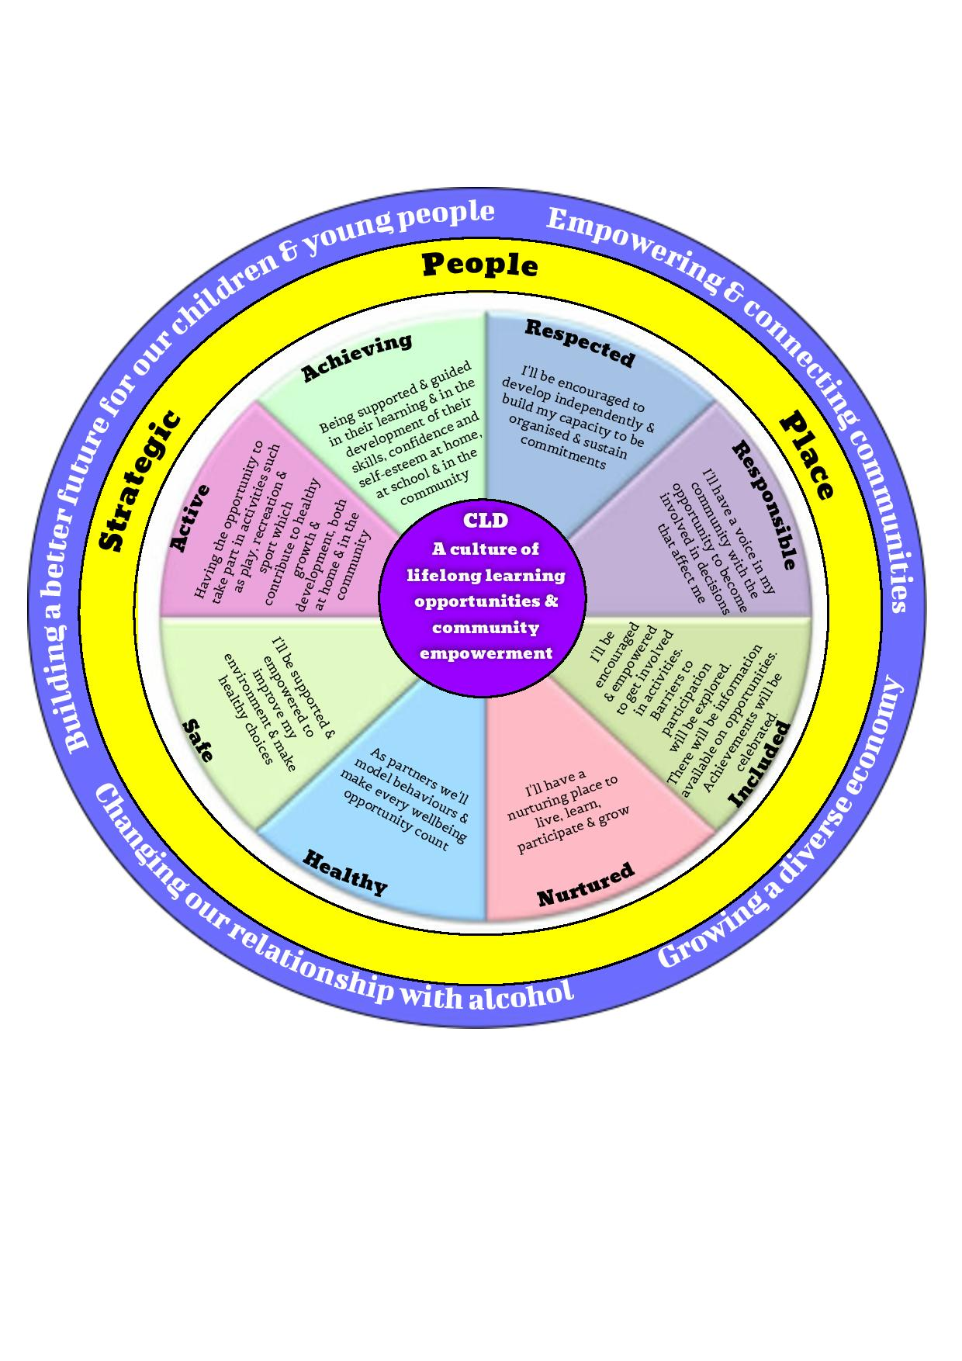

Prospects

Publicity

***Adapted from Scottish Government GIRFEC***

**The GIRFEC themes are represented by the coloured sections in the inner circle**

**Resource Context**

Whilst the legislative base for CLD has never been stronger, plus the need for individuals and communities to have access to community learning and development support, partners and communities are operating in extremely challenging circumstances.

Moray Council is required to make £12 million savings by the end of 2019-2020 and the public will be consulted on some of the decisions on savings and solutions.  The current forecast indicates that, if no action is taken to operate within our income, the Council does not have the reserves to cover the shortfall

The Third Sector has to create more funding bids for less reward as the market is increasingly competitive. Funding from the local authority has diminished and the expectations of in-kind support to networks although willing, cannot be realised due to their own sourced funding restrictions.

Staff in the NHS and Health and Social Care, have funding streams which work in collaboration with partners to identify and address needs. This capacity to co-produce and deliver capacity building in partnership will be significantly reduced with the predicted savings.

With this backdrop to services a pragmatic approach to consultation was required to develop the CLD Plan to ensure that unrealistic expectations were not raised. Inputs and sessions were delivered to a range of organisations from the Federation of Village Halls to the Community Engagement Group, the CLD network meetings, and a workshop delivered at the annual tsiMORAY “Join the Dots” conference for activists to “CLD: the road to travel” workshops targeting local people. 14 specific equalities groups were met with to listen to their needs and aspirations plus improvement ideas for provision. A survey monkey targeting the secondary school pupils had a poor yield.

All of the improvement suggestions that were raised were listened to and almost all have informed the targets and ongoing discussion in the strategy group.

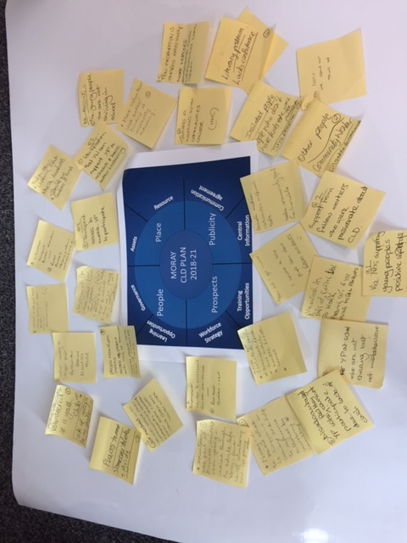

***“Join The Dots”***

**tsi**MORAY Event - 25th March 2018

**Moray Local Outcomes** **Improvements Plan Priorities**

The vision of the Community Planning Partnership for Moray is **raising aspirations through expanded choices, improved livelihoods and wellbeing.** In seeking to achieve this four main priorities have been identified to drive the work through consultation with partners:

1. **Growing, a diverse and sustainable economy;**
2. **Building a better future for our children and young people in Moray;**
3. **Empowering and connecting communities;**
4. **Changing our relationship with alcohol.**

Analysis of the extensive data confirms the main issues for the Community Planning Partnership include:

* Above average percentages of older people, particularly in the more rural and coastal areas which creates challenges in relation to service delivery and access and social isolation
* Low wage economy and reliance on a small number of industries impacting on our economic diversity
* Influence of the MOD on population dynamics and reliance upon it for jobs increasing our reliance on this industry for our economic sustainability
* And outward migration of young people leaving school for higher education and a poor rate of return in later years
* Variation in outcome for young people in relation to attainment and post-school destination impacting on their choices for the future
* Variation in outcome for smaller communities within Moray-particularly prominent in Elgin but also evident in other areas and a town/rural divide seems to emerge
* Our geography/rurality and subsequent access to services and social isolation
* The impact of Public Sector constraints.

Further work was done looking at the variation in communities and their outcomes and seven communities were identified to engage with local people and offer focussed partnership support. As it is a learning curve for everyone involved two different approaches will be taken by the Partnership to see what works best for local people and communities. In New Elgin East the proposal is to “develop an environment of increased aspiration that will lead to increased attainment, better health and wellbeing and increased involvement in their community.” In Buckie Central East the proposal is to have “an increase in attainment, increased employability and a greater voice in community affairs.” Central to this will be to build the outcome measures with the community so they own and drive the change. As knowledge and understanding grows, new prioritised communities and their themes will be progressed.

An information mapping exercise has been completed to identify local services and support for the Family Information Service <http://morinfo.moray.gov.uk/show_details.php?org=1>

**Unmet Need**

It is part of the regulations that Partnerships must highlight the areas that they are unlikely to be able to address over the plans cycle. Opportunities to discuss the gaps and potential solutions will be part of the strategic work and it is recognised that these will change with emerging opportunities. The following issues have been highlighted from meetings with community groups, practitioners and equality groups:

**PEOPLE**

The lack of free crèche provision or respite care supporting classes and initiatives is a barrier for parents/carers to access learning opportunities. Local delivery of provision is generally preferred however numbers to sustain provision and limited rural transport to be able to attend opportunities is lacking.

Consistent universal youth work opportunities are not available in each community and may not be covered by Third Sector partners leading to limited achievement for young people. A consequence of the timetable change to the 33 period week means that some of the lunchtime opportunities are not sustainable, and rural young people in particular will miss out.

Learning provision for non-accredited activities, below national 4 awards are limited and may not be picked up through future leisure class provision.

There is a lack of capacity to support fully the transitions from child to adult services, plus life and work transitions. Demand for support via volunteers is high but the infrastructure to sustain and support the volunteers is very limited.

As there are no CLD Service practitioners at a local level and Third Sector short-term contracts are the norm, this limits flexibility to respond promptly to community need and build relationships in local communities through a CLD “presence.” The CLD Strategic Partnership will endeavour to cover this but it is realistic to say that rural communities in particular will miss out.

**PLACE**

For a number of community groups the current let charges for hall amenities prevents them from accessing and initiating provision. Already press coverage from some of the newly transferred community asset transfers have highlighted hall committee intentions to reduce the tariffs, but whether this can be sustained once all the overheads are accounted for will be challenging.

As the culture changes from statutory led to community led projects and provision, there will be a need to support initiatives when the community is ready to take them on. Funding to support and sustain this, at the time of need, may not be available.

**PUBLICITY**

There will be a growing reliance on voluntary groups and third sector organisation to cascade information on top of their core business. The lack of core administrative infrastructure means that some individuals and groups will miss out. It also assumes that all groups have a digital footprint.

**PROSPECTS**

As organisations find it harder to fund training and release staff we need to find new ways of offering and cascading learning. Practitioners cannot attend the networks and meet as they previously did which impacts on their knowledge and partnership working, leading to isolation. The digital solution does not meet all learning styles. There is a lack of opportunity to embed succession planning for staff with fewer opportunities to shadow experienced workers. The opportunity to go outside Moray to see, experience and learn about other provision has also reduced.

**Strategic Partnership Targets**

Partners completed the targets for their own service over the lifetime of this plan, which was the first time that this had been mapped and information shared. Monitoring of these targets, which include the post inspection improvement plan, will populate annual CLD reports and publicity. From this process partners then focussed on what the added value was of the partnership to channel the focus and delivery. This was supported by the Education Scotland post inspection support sessions in August 2018. Whilst we are starting a process of fuller accountability and understanding it is early days in the grounding of CLD practice and performance management which the partnership are committed to deliver.



***“Evaluation Tool”***

December 2017



|  |  |
| --- | --- |
| **Target** | |
|  | People |
|  | Place |
|  | Prospects |
|  | Publicity |
|  | Strategic |

|  |  |
| --- | --- |
| **LOIP priority** | |
| L1 | Growing a diverse economy |
| L2 | Building a better future for our children & young people in Moray |
| L3 | Empowering & connecting communities |
| L4 | Changing our relationship with alcohol |

**Partnership Strategic Targets: People**

|  |  |  |  |  |  |  |  |
| --- | --- | --- | --- | --- | --- | --- | --- |
| **LOIP themes: 1,2,3,4** | | | **Outcomes** | | | **Performance** | |
| **The Need** | **Baseline Data** | **Input** | **1st Year** | **2nd Year** | **3rd Year** | **Measure** | **Lead** |
| The learning offer will be explicit in core partners delivery | 2018 Inspection evidence:  Community based provision less likely to highlight the learning offer;  Low take up of learning offer training. | Training sessions on composing the learning offer delivered annually through Moray Community Training Calendar and rolled out by partners | Strategic CLD Partners are confident in describing and detailing their  Learning offers and supporting staff to do likewise | All staff are using the language of “learning offer” and encouraging networks to do so | “Learning offer” is routinely used and practitioners are comfortable with this language | Increase in number of training opportunities delivered and attendance  ERDP/staff appraisal confirms understanding and application  Quality assurance measures confirm increase in language and sight of descriptors | CLD Support Officer |
| Deliver a core range of achievement and attainment opportunities for young people | Inconsistent learning offers across Associated Schools Groups. | Engagement team clarified offer; External funding sourced;  Capacity building of volunteers to co-deliver provision | Gaps identified & information shared to wider networks to find solutions | Gaps identified & information shared to wider networks to find solutions | Gaps identified & information shared to wider networks to find solutions | Wider achievement annual reporting reflects improvement across ASG’s; 10% Increase in place based projects through Project Development Tool  10% increase in recruitment of volunteers | Children’s Wellbeing Manager |
| Improve the deployment of volunteers in supporting CLD provision | Partners use different systems to support, train and manage volunteers. | Gather core data; Invite volunteers to contribute to reviewing their experiences; Update existing systems/reports | New materials and refreshed training created to meet needs | Improved understanding of how we work with volunteers as a partnership | Volunteers invited to lead recruitment opportunities and describe CLD | Recruitment of volunteers sustained or increased subject to supports available.  Report to Community Planning Board on the use of volunteers  Case-studies contributed by each partner to the CLD pages. | **tsi**MORAY & ALL Partners |



|  |  |
| --- | --- |
| **Target** | |
|  | People |
|  | Place |
|  | Prospects |
|  | Publicity |
|  | Strategic |

|  |  |
| --- | --- |
| **LOIP priority** | |
| L1 | Growing a diverse economy |
| L2 | Building a better future for our children & young people in Moray |
| L3 | Empowering & connecting communities |
| L4 | Changing our relationship with alcohol |

**Partnership Strategic Targets: Place**

|  |  |  |  |  |  |  |  |
| --- | --- | --- | --- | --- | --- | --- | --- |
| **LOIP theme: L3** | | | **Outcomes** | | | **Performance** | |
| **The Need** | **Baseline Data** | **Input** | **1st Year** | **2nd Year** | **3rd Year** | **Measure** | **LEAD** |
| To use an asset based approach in our work to harness knowledge, skills and resources in communities to progress locality plans and place based approaches. | Locality plans process piloted in 2 areas with 5 further areas identified; | Partnership engagement with local people to develop core groups; support local priorities and evaluate pilot methodology; | Qualitative information behind the SIMD statistics emerged and key local issues identified | Partners and services prioritise budget to local peoples identified needs/solutions | Partners respond to capacity building needs of  Localities to build sustainability | Number of local people and partners engaged;  Locality Plan in place;  Evaluation reports on pilots | CSU |
| 7 Community Asset transfers completed for halls and community centres with 14 notes of community interest for wider CATS | Community Support Unit partnership agreements and ongoing evaluation feedback | Local groups have governance arrangements in place and are confident in taking forward the leases for their initiatives | CAT members have the training and skills to progress formal ownership of the assets; Applications for transfer submitted to Moray Council | Increase in confidence that communities can manage assets; Issues identified that require more input | Number of leases signed and business plans developed;  Number of support agreements in place;  Number of assets successfully transferred;  Qualitative testimonies from community groups | CSU |
| 7 Participatory Budgeting funding tranches completed: Money for Moray (4); Bucks for Buckie (1); You Choose (2); | Community Engagement Group advice/support;  Partners pursue funding as announced with groups as appropriate. | Increased awareness by communities of how to access and participate in Participatory Budgeting projects | Community groups will have insight into the process of how to contribute and progress the transformation of Council services with the target of 1% of the resource budget. | Evidence of co-design of Moray Council services and development of new delivery methods | Increase in the number of applicants for project initiatives;  Completed funding reports;  Number of groups interested and engaged in future provision delivery proposals;  Qualitative testimonies from community groups | Third sector groups  CSU |

|  |  |  |  |  |  |  |  |
| --- | --- | --- | --- | --- | --- | --- | --- |
| **LOIP theme: L1,2,3,** | | | **Outcomes** | | | **Performance** | |
| **The Need** | **Baseline Data**  **2017-2018:** | **Input** | **1st Year** | **2nd Year** | **3rd Year** | **Measure** | **Lead** |
| Ensure the CLD workforce is skilled with access to opportunities and accreditation | 300 participants attended Community Training Calendar sessions;  4xHow good is our focussed themed sessions delivered with 202 participants;  19 Moray practitioners at (free)North Alliance Conference 2018;  170 people attended “Join the Dots”;  19 members of the CLD Standards Council;  3 CLD network meetings;  No CLD work-based route students and PG Cert Students | Create a CLD workforce strategy;  Deliver a community training calendar;  Education Scotland support sessions post inspection;  North Alliance 6 audio meetings; current secretarial role;  2 themed events linked to Regional Improvement Collaborative themes;  3 CLD network meetings per year; | Increased awareness of progression steps for learners | Increased co-delivery of training opportunities and CLD signposting | Positive CLD testimonies collected from key partners highlighting a range of applicable destinations | Workforce strategy completed and monitored; 20 testimonies collated per annum.  Annual calendar produced with 10 courses; 2 quality indicator focussed sessions delivered;  Core sessions delivered; partners progressed within networks and needs identified.  Family Learning & Evaluative writing sessions delivered  Increased number of community groups represented at annual **tsi**MORAY event  10% Increase in membership  of CLD Standards Council; Network meetings reported annually;  1 student supported on Higher Education | SDS/CLDSO  CLD Support Officer  CLD Support Officer  CLD Support Officer  tsiMORAY  ALL Partners  CLD Support Officer  Budget Holders |



|  |  |
| --- | --- |
| **Target** | |
|  | People |
|  | Place |
|  | Prospects |
|  | Publicity |
|  | Strategy |

|  |  |
| --- | --- |
| **LOIP priority** | |
| L1 | Growing a diverse economy |
| L2 | Building a better future for our children & young people in Moray |
| L3 | Empowering & connecting communities |
| L4 | Changing our relationship with alcohol |

**Partnership Strategic Targets: Prospects**



|  |  |
| --- | --- |
| **Target** | |
|  | People |
|  | Place |
|  | Prospects |
|  | Publicity |
|  | Strategy |

|  |  |
| --- | --- |
| **LOIP priority** | |
| L1 | Growing a diverse economy |
| L2 | Building a better future for our children & young people in Moray |
| L3 | Empowering & connecting communities |
| L4 | Changing our relationship with alcohol |

|  |  |  |  |  |  |  |  |
| --- | --- | --- | --- | --- | --- | --- | --- |
| **LOIP themes:L1,2,3,4** | | | **Outcomes** | | | **Performance** | |
| **The Need** | **Baseline Data** | **Input** | **1st Year** | **2nd Year** | **3rd Year** | **Measure** | **Lead** |
| CLD is not understood by the public and some service providers/agencies | Recent inspection activity highlighted that some agencies and the public did not recognise CLD;  Gaps in knowledge about CLD at all levels.  Inconsistent gathering and use of impact data. | Creation of a strapline for CLD;  Make every opportunity count for CLD project created and applied by partners;  Systematic provision of CLD stories to “Inside Moray “ and other media; Engagement of learners in ideas for improvement;  Development of CLD Celebration month;  Creation of CLD page on **tsi**MORAY website;  Annual CLD partnership report created | Strapline in place and utilised at events;  Increase in reported CLD conversations ; | Practitioners and Leaders see and recognise CLD activity and capture impact | An increase in understanding, ownership and contribution in the creation of the third CLD Plan by community groups. | Strapline in place & materials produced and evidenced; Training session created and rolled out, with reporting on usage by partners; Media presence monitored and gaps identified; Moray Adult Learners Forum re-established and priorities supported;  CLD Celebration month delivered annually with a 10% increased involvement;  Impact of activity gathered from each partner. | All Partners |

**Partnership Strategic Targets: Publicity**



|  |  |
| --- | --- |
| **Target** | |
|  | People |
|  | Place |
|  | Prospects |
|  | Publicity |
|  | Strategy |

|  |  |
| --- | --- |
| **LOIP priority** | |
| L1 | Growing a diverse economy |
| L2 | Building a better future for our children & young people in Moray |
| L3 | Empowering & connecting communities |
| L4 | Changing our relationship with alcohol |

**Partnership Strategic Targets: Strategic**

**Partnership**

|  |  |  |  |  |  |  |  |
| --- | --- | --- | --- | --- | --- | --- | --- |
| **LOIP theme: L3** | | | **Outcomes** | | | **Performance** | |
| **The Need** | **Baseline Data** | **Input** | **1st Year** | **2nd Year** | **3rd Year** | **Measure** | **Lead** |
| Improve the systematic gathering analysis and sharing of performance information across the strategic partnership | Limited performance information currently shared at the strategic partnership | Structure for sharing and scrutiny of information in place as per terms of reference; Scrutiny group created to analyse returns;  Focussed review of findings quarterly | Partners are confident in what information to collect and share | Partners can identify and explain or question trends.  Improved partnership understanding of others services. | Trends can be acted on and improvement measures devised from a position of shared understanding.  Contributing to improved scoring of Quality indicator 1.1 | Quarterly reports completed and submitted by all members;  Annual performance report submitted to Community Planning Board | Chair  CLDSO &  Research Information Officer |
| Inconsistent use of learners voice in service delivery and structures | Information is fragmented on gathering the learners’ voice.  Scottish Youth Parliament members have requested a Youth Rights and Participation Strategy.  Moray Adult Learners Forum ceased in 2016.  Terms of reference commits partners to gather the information | Partnership consensus on how this will be progressed and monitored.  Core group identified to take forward and a range of approaches identified. | Practice established to gather learners experiences across provision/activity | Impact on service delivery as a result of learners experience | Consistent learners’ voice gathered and acted on.  Some learners and community groups will be engaged in gathering case-studies/experiences | Case-studies built in each practice area: youth work, adult learning and community development  Increased learner involvement in initiatives.  Youth Rights & Participation strategy in place | Moray College UHI  Opportunities for All Officer |

**Appendix 1 -** **Membership**

The CLD Strategic Partnership is made up of the following representatives:

* tsi**MORAY** <http://www.tsimoray.org.uk>
* LEAD Scotland <http://www.Lead.org.uk>
* NHS Grampian <http://www.nhsgrampian.org>
* Skills Development Scotland <http://www.skillsdevelopmentscotland.co.uk>
* Moray College UHI <http://www.moray.uhi.ac.uk>
* Moray Council <http://www.moray.gov.uk>
* Community Engagement Group <http://www.yourmoray.org.uk/ym_standard/Page_104947.html>

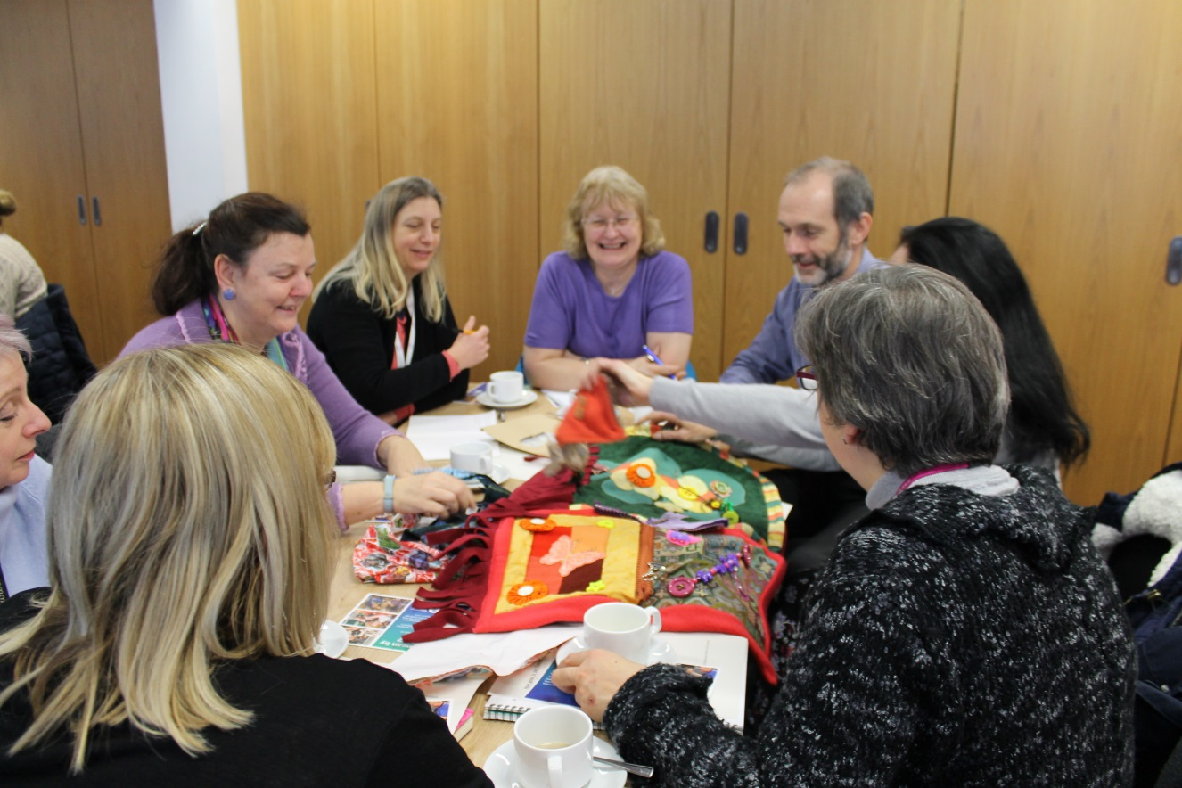

**“How Good Is Our Family Learning?”**

18th January 2018

**Appendix 2 –** **Glossary of terms**

**ASG:** the educational groups i.e. nurseries, primaries that feed into a secondary school catchment area

**CCB:** Community Capacity Building: Community capacity building is one of three strands of community learning and development in Scotland. It describes a particular way of working with and supporting communities - to build skills and experience, increase opportunities, and enhance involvement in the decisions that affect them. This can involve developing confidence, skills, structures and knowledge, to increase the opportunities communities have to make a real difference to the services, activities and changes that take place in their area.

**CLD:** Community Learning & Development: The purpose of community learning and development (CLD) is to empower people, individually and collectively, to make positive changes in their lives and in their communities through learning.

**CLD** **Regulations 2013**: The statutory legislation which stipulates the requirement to produce a three year CLD Plan

**CLD Standards Council**: The registration body for everyone involved in CLD in Scotland.

**CLD Workforce:** Paid or unpaid CLD practitioners

**Communities of interest**: Groups of people who share a common identity (e.g. Men’s Sheds) or common experience (e.g. teenagers).

**CSU**: Community Support Unit: local authority staff within the Chief Executives department who support community capacity building and consultations.

**Education Scotland:** the Executive Agency of the Scottish Government, tasked with improving the quality of the Scotland's education system

**ESOL:** English for Speaker of Other Languages, ESOL classes and groups are supported by staff and volunteers.

**Family Learning**: “an approach to engaging families in learning outcomes that have an impact on the whole family” Education Scotland.

**HMIe**: Her Majesties Inspectorate of Education: The government body charged with reviewing, inspecting and supporting the quality of CLD provision in Scotland.

**LEAD Scotland:** A third sector organisation set up to widen access to learning for disabled adults and carers across Scotland though delivery and support of formal, informal and non-formal education.

**Learning Offer:** the tailored learning and development activity to meet the needs of individuals or groups

**MCPP,** Moray Community Planning Partnership**:** The Partnership is the overarching body which brings together business, voluntary and community organisations to better plan, resource and deliver quality services that meet the needs of local people.

**Opportunities for All**: Every young person who is leaving compulsory education and moving on to further learning, training or employment should receive an offer of post-16 learning. The Scottish Government made this commitment to improve young people’s participation in learning or training (and, ultimately, employment) between the ages of 16 and 20 and beyond.

**Partners:** individuals, groups and organisations who contribute to the opportunity or action

**PB**, Participatory Budgeting: Defined as ‘local people having direct decision making powers over part of a public budget.’ It is a form of participatory democracy.

**RIC, Regional Improvement Collaborative, or Northern Alliance:** brings together a range of professionals with a focus on supporting teachers and other school staff working with children and young people to improve their wellbeing, attainment and outcomes. They will provide targeted advice and support in order to drive improvement, making use of all available evidence and data. They will help teachers to access the practical improvement support they need, when they need it.

**North Alliance:** a partnership of third sector and local authority CLD practitioners who strive to share practice and skills in the 7 northern authorities to build the capacity of the workforce and reduce professional isolation.

**SDS,** Skills Development Scotland: SDS is the national skills body charged with supporting the people and businesses of Scotland to develop and apply their skills. SDS was formed in 2008 as a non-departmental public body, bringing together careers, skills, training and funding services and works with partners to support individuals to reach their potential; help make skills work for employers and improve the skills and learning system.

**Stakeholders**: shorthand term for CLD learners, communities and communities of interest.

**tsiMORAY:** Third Sector Interface provides advice, support, training and guidance to develop the voluntary sector in Moray. It is a membership organisation.

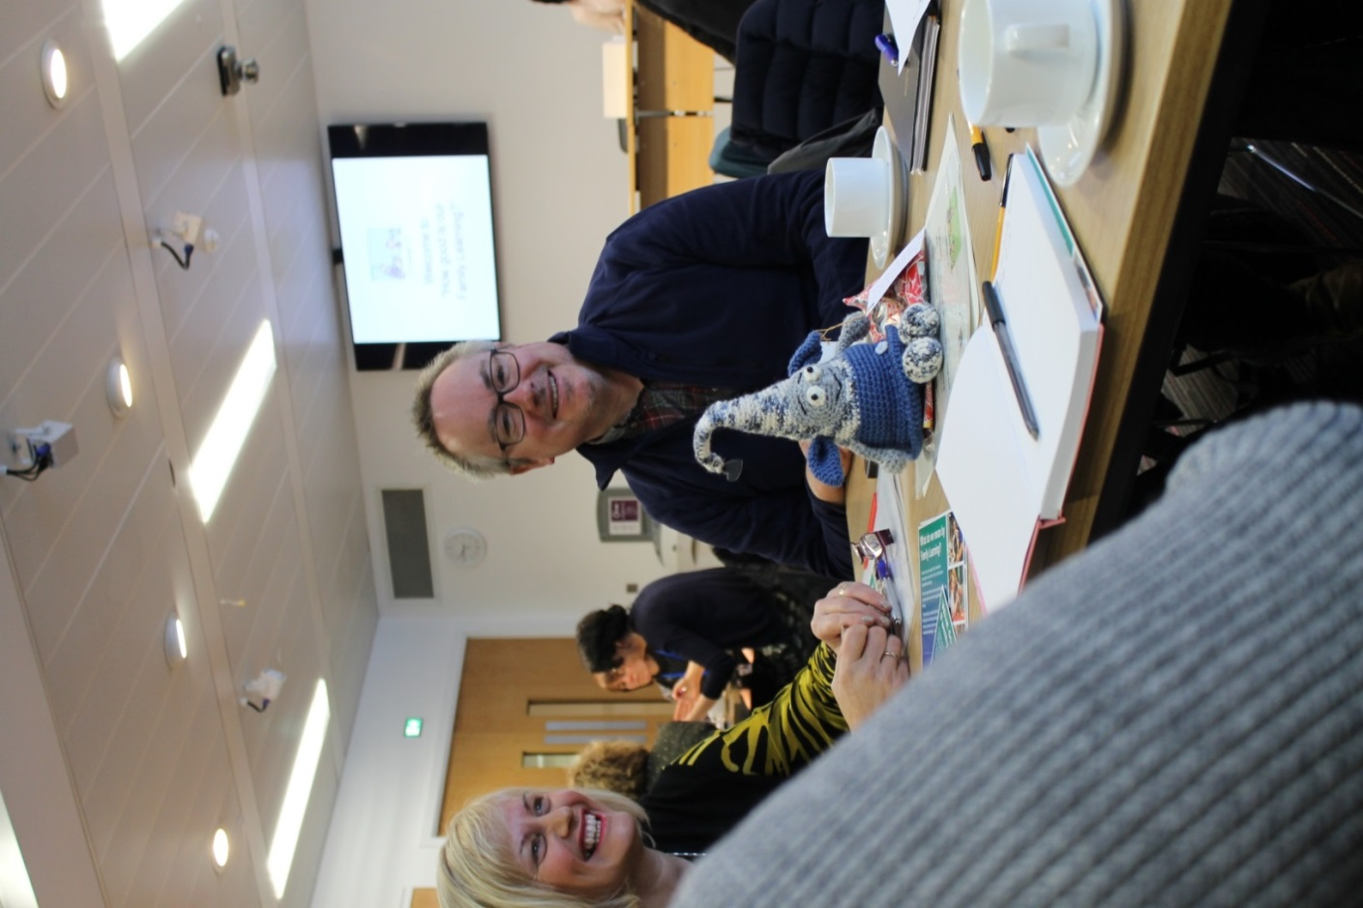

**“How Good Is Our Family Learning?”**

18th January 2018

**Appendix 3 – CLD Outcomes created from the national Youth Work sector, CLD Managers and Third Sector partnerships**

|  |  |  |
| --- | --- | --- |
| **Youth Work** | **Adult Learning** | **Community Development** |
| * Young people are confident, resilient and optimistic for the future | * Adult learners are confident, resilient and optimistic for the future | * Communities are confident, resilient and optimistic for the future |
| * Young people manage personal, social and formal relationships | * Adult learners develop positive networks and social connections | * Communities manage links within communities and to other communities and networks |
| * Young people create, describe and apply their learning and skills | * Adult learners apply their skills, knowledge and understanding across the four areas of life | * Community members identify their capacities, learning and skills, enhance them and apply them to their own issues and needs |
| * Young people participate safely and effectively in groups | * Adult learners participate equally, inclusively and effectively | * Community members form and participate equally, inclusively and effectively in accountable groups |
| * Young people consider risk, make reasoned decisions and take control | * Adult learners are equipped to meet key challenges and transitions in their lives | * Communities consider risk, make reasoned decisions and take control of agendas |
| * Young people express their voice and demonstrate social commitment | * Adult learners express their voices, co design their learning and influence local and national policy | * Communities express their voice and demonstrate commitment to social justice and action to achieve it |
| * Young people’s perspectives are broadened through new experiences and thinking | * Adult learners critically reflect on their experiences and make positive changes for themselves and their communities | * Community members’ perspectives are broadened through new and diverse experiences and connections |

**Thank you for taking the time to read our plan.**

**If you have any questions please do not hesitate to contact:**

CLD Support Officer, Moray Council Tel 01343 56 3989

