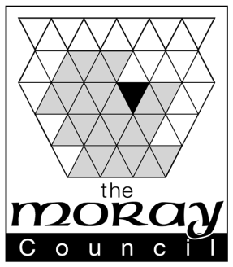
Notification of Public Entertainment Event
This form must be submitted to licensing@moray.gov.uk as early as possible after the booking of the event and at least 35 working days before the event
Public Entertainment Licence Number: ……………………………………………………………
Date(s) and time(s) of event:
…………………………………………. ………………………………………….……………………
………………………………………………………………………….…..........................................
Description of event:
…………………………………………………………………………………………………………..
…………………………………………………………………………………………………………..
…………………………………………………………………………………………………………..
…………………………………………………………………………………………………………..
…………………………………………………………………………………………………………..

Please note: Based on the type of event you may be asked to discuss or provide such things as: additional security, dispersal plans, risk assessment etc.

Contact Name:……………………………………………………………………..............................
Contact e:mail:………………………………………………………………………………………….
Contact Phone Number……………………………………………………………………………….

The information on this form will be passed to Moray Council Licensing Standards Office and other consultees for inclusion in the Events Inspection Visit schedule.

