Insurance
All Council staff and volunteers working on the Award are vetted to ensure that they are suitably qualified and competent. The staff, volunteers and the young people taking part in activities organised by the Council are covered by personal accident and third party insurance.

Activities outwith school or Council arrangements are not covered by the Council’s insurance. Therefore you are strongly advised to arrange private insurance cover for your child and/or seek written assurances from the provider with regard to safety standards, the qualifications and competencies of instructors, and their insurance cover in the event of a young person suffering an accident or loss during those activities.

Adult Volunteering
The Duke of Edinburgh’s Award helps develop young people, building confidence, self-reliance and social skills. These life skills are highly rated by employers and universities.
If you have particular talents as an administrator, an arts or music teacher or you have an outdoor adventurous activity qualification you might consider helping your child’s school deliver the Duke of Edinburgh’s Award experience.
Training is available to enable you to support young people through the Award. If you are interested please contact the school or
Moray Council’s DofE Staff on 01343 813614 or DofEMoray@moray.gov.uk

Education and Social Care
Karen Delaney
CLD Officer
Moray Council Headquarters
Telephone: 07800 670692
Email: Karen.delaney@moray.gov.uk
www.moray.gov.uk

December 2019
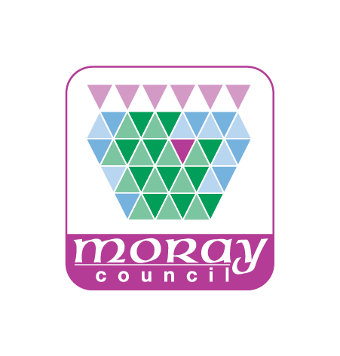
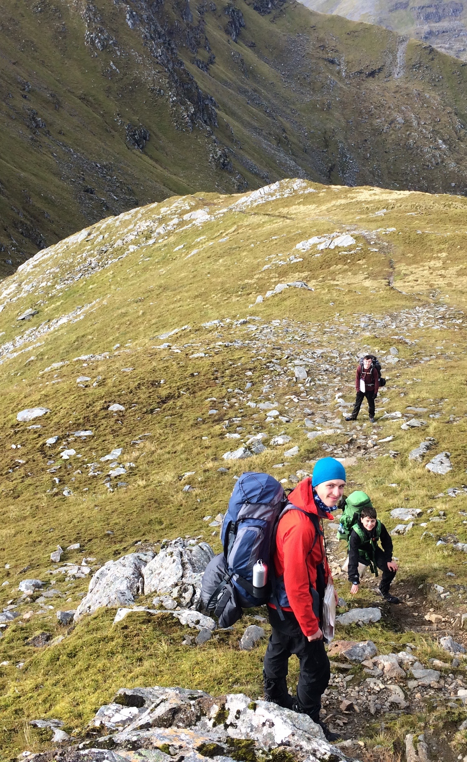
Introduction to
The Duke of Edinburgh’s Award

For Parents and Guardians
in Moray

What is the Duke of Edinburgh’s Award

The Duke of Edinburgh’s Award is the world’s leading achievement based award; recognised and valued by universities and employers.
It is valued because of the breadth of involvement and the commitment young people need to show to achieve the award.
Whilst the onus is on young people to complete their Award, they will need support from parents/guardians. This leaflet outlines the structure of the Award and how you can support your son/daughter.

Levels and Sections
The Award is organised into 3 levels:

Bronze | Silver | Gold

Each level builds on the previous one; using the skills learnt to meet new challenges.

Each level has 4 elements (known as sections). These are:
Volunteering, Physical, Skills and an Expedition.
The sections provide a broad selection of challenges to help develop a wide range essential skills for life and work.

Individual Commitment
Young people normally start their Duke of Edinburgh’s experience at Bronze level. They can begin working on all their sections as soon as they have enrolled.
They must choose the activities they want to undertake for each section. With a wide range of activities available, they will be able to find activities that match their interests. Normally young people can use activities that they already enjoy, such as attending youth organisations, playing a sport or learning to play a musical instrument.
At Bronze level, each section requires a commitment of one hour per week which must be sustained for a minimum of 3 months (plus an additional 3 months on one section)

For the expedition section young people need to complete a training package, a practice expedition and a qualifying expedition. The training and the expeditions can be tailored to suit the level of the award and the needs of the young people taking part. For Bronze, the expeditions must include two days walking and an overnight camp.
More information on the levels and sections of the Award can be found at https://www.dofe.org

Parental Support
Whilst the emphasis is on the young people giving time and commitment to achieve the Award, your child/ward will need support.

For example your child may need lifts to and from attending sessions for their Volunteering, Physical and Skills sections or to take part in expedition training. These activities may be carried out in school, sports club, community centre or another location.

Cost
There is a £22 enrolment fee for Bronze and Silver (£29 for Gold) which helps DofE Scotland pay for administrating the Award and provide a welcome pack and certificate. The pack will help the young person record their progress through the Award.
There is also an expedition fee of £10 to £20 (dependent on the level of the award) which helps train the adult volunteers needed to supervise expeditions.

Making Sure Your Child is Properly Supervised
The school or Moray Council will provide PVG cleared volunteers to support expedition training and supervise your child whilst on their expeditions. Activities for the other sections may also be carried out by teaching staff or other volunteers already PVG cleared.

However, if your child wishes to take part in an activity run by other agencies such as voluntary clubs, commercial organisations or local groups, eg: a sports club, a dance class or a guitar tutor, then it is your responsibility to ensure that the adult supervising that session is trustworthy. The Council does not vet these agencies, their staff or volunteers, or the standards of work that they provide.

