Ref: DofE/MDEAC/01

Date:

Dear Participant/Parent/Carer.

Expedition Fees

We are writing to you on behalf of Moray Duke of Edinburgh’s Awards Committee, the charity that supports The Duke of Edinburgh’s Award through the Moray Council’s DofE Scheme.
The Moray DofE Awards Committee supports the continuation and development of the whole Award and in particular the expedition section. To support expeditions, the Committee has raised funds to purchase equipment for each centre/school. The Committee needs to continue raising funds to help support the maintenance of this equipment and contribute towards the training of the adult volunteers who give their time and commitment to facilitate young people in achieving their DofE Award.
As one strand of their fund raising efforts, the Moray DofE Awards Committee asks each participant undertaking their expedition section to contribute a nominal fee.
We ask you to pay your expedition fee to your DofE Coordinator at your DofE centre/school, who will pass it on to Moray Duke of Edinburgh’s Awards Committee.
Payment methods
Expedition fees for the 2019/20 season are £10 for Bronze, £15 for Silver and £20 for Gold.
Your DofE Coordinator will collect your expedition fee. If paying by cheque please make this payable to ‘MLAC’ which is the account name for the charity.
On behalf of Moray DofE Awards Committee, and all the adults who volunteer with DofE across Moray, we thank you for this contribution to supporting the Award.
Yours faithfully
Chris Gransden

on behalf of
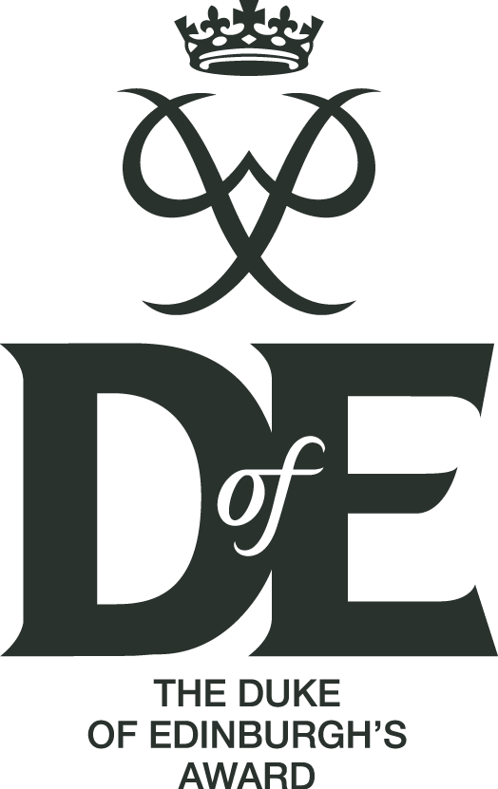
MORAY DUKE OF EDINBURGH’S AWARDS COMMITTEE

