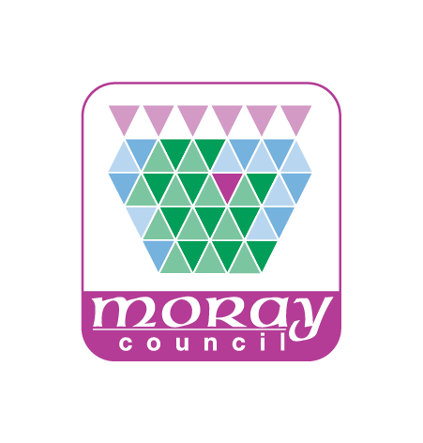

DofE PARTICIPANT PLACES AND WELCOME PACK ORDERING PROCESS
DofE introduced bulk purchasing of participant places and welcome packs to save Centres and LOs money, in terms of postage and packing, and administration time. Moray Council no longer have the budget flexibility to hold credits for participant places for Centres. From 2016/17 a requirement for Centres to bulk buy credits was included in the Partnership Agreements between Moray Council and each Centre.
Ordering Process. The ordering process is illustrated in the attached flow chart. This leaflet gives further guidance.
Centre Coordinators need to calculate the number of credits/welcome packs they require for the DofE season. This can be done by estimating probable enrolment numbers or assigning an enrolment period. Centres can place their orders in more than one block if they need to enrol participants later in the season.
The Centre Coordinator then places an order through the DofE Moray Office for the participant places they need for the season. DofE Moray will order credits from DofE Scotland. DofE Scotland will issue eDofE credits to the DofE Office. Once the credits have been received, DofE Moray will allocate the credits to the Centre’s eDofE account. Welcome packs will be posted directly to the Participants.
Payments. The participant will pay their enrolment fee to the centre. Centres may choose for the Coordinator to collect enrolment forms and fees together, or for fees to be collected by the Centre’s reception/admin staff. All DofE fees must be banked under the Centre’s (DofE) budget. The Moray Council on-line payment system can be used to pay enrolment fees. DofE Moray will track on-line payments and ensure that these are not included in invoices to Centres. The DofE manager will invoice centres for enrolment fees at the end of the financial year. On receipt of the invoice the Centre reception/admin staff are to transfer funds to the Council DofE fund.
This change will give the schools more control of enrolments and make it easier to coordinate enrolment forms with payments.
Allocation of Participant Places. The Centre is responsible for allocating eDofE credits to their participants. Centres must to retain enrolment forms until each participant has completed their DofE Award.
Please note that DofE Moray has previously paid postage and packing on each order. This charge will now be included in the invoices sent to Centres.
BULK ORDER PROCESS
Centre Admin
Reconciles Invoice against Payments Received
Centre Admin
Receives Payments
Centre Admin
Processes Invoice
(inc Post and Packaging)
DofE Manager
Sends Invoice to Centre
Centre Admin reconciles Bill against number of payments received
Leader passes cash and cheque payments to Admin for processing
DofE Office
Allocates Credits to Centre
DofE Office
Receives Credits
Centre Leader receives Enrolment Form and cash payments
Centre Leader retains Enrolment Form for recording and entering participant on eDofE
Leader requests DofE Credits based on total numbers of enrolments
(Bulk Purchase)
Enrolment Form
Centre Leader receives Form and Payment
Request Credits
DofE Office
Processes Request
DofE Manager
Orders Welcome Packs
Centre Admin transfers funds to Moray Council DofE Account
Payment
Online
Cheque
Cash
Participant Enrolment

