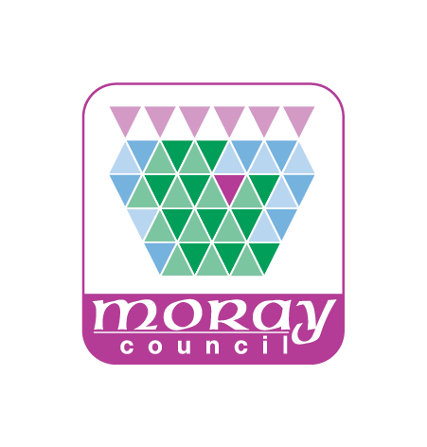
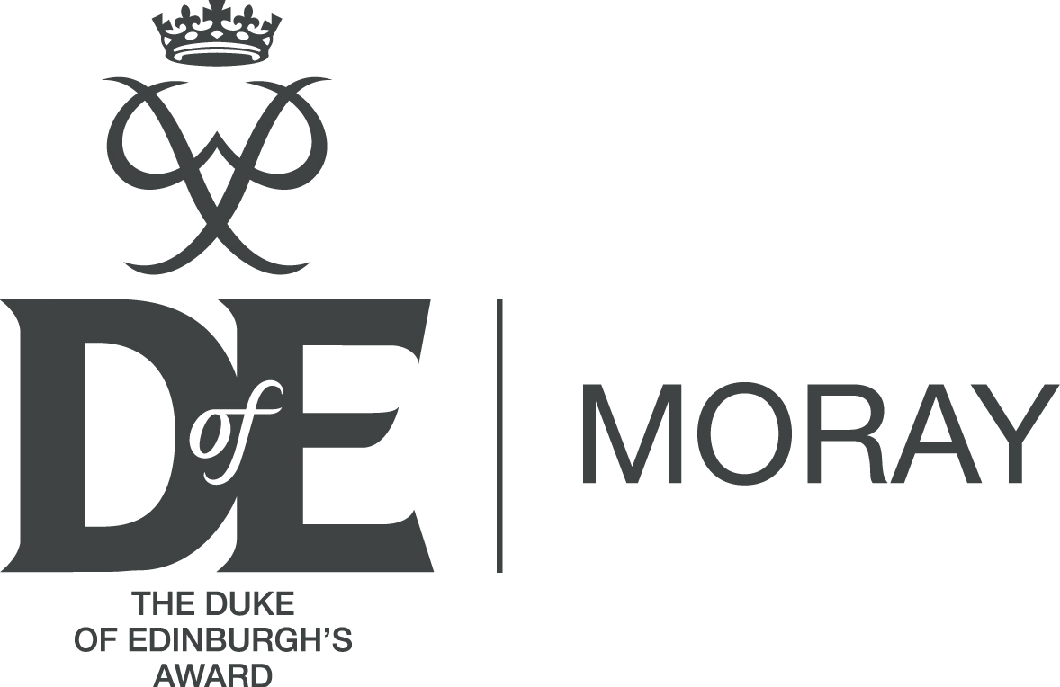

DofE volunteers Travel Claim procedure
Volunteer Travel expenses are to be submitted using the Travel & Subsistence Claim Form for Non Moray Council Employees.
Due to changes in the allocation of budgets the process for submitting Claims will also be subject to change.
From April 2019 Claims need to be submitted to Karen Delaney (DofE Manager). Karen will arrange for your expense claim to be paid.
Claims can be emailed to karen.delaney@moray.gov.uk or posted to Karen at the Council HQ Annex in Elgin.
A Travel Claim Form should be completed each month in which you are claiming travel expenses. Forms with more than one month’s claims on it will not be accepted.
Claims must be supported by VAT receipts. Receipts must be attached to the Travel Claim Form.
Please ensure you sign the form. Financial department rules mean that electronic signatures cannot be accepted. Claim forms must include original signatures. Therefore, if e-mailing the form you will need to print, sign and then scan the document before sending it. Note: forms will not be processed without a signature.

Updated April 2019

