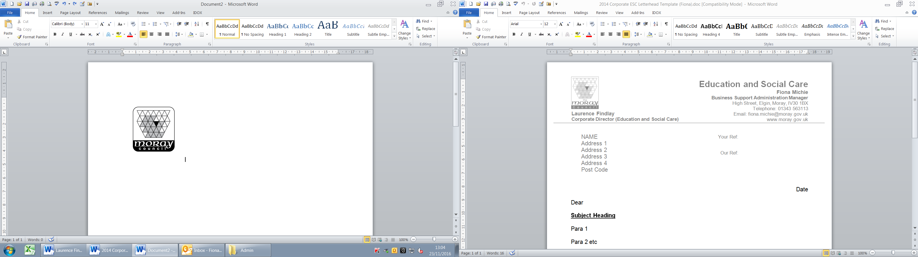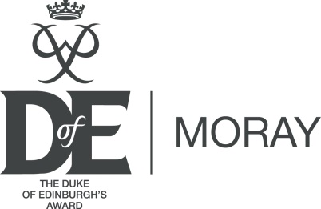

Education and Social Care

Children’s Wellbeing (Engagement)



The Duke of Edinburgh’s Award (DofE Moray)

Volunteer Application Form/Registration

Full Name ……………………………………………………………………………………….…

Address ………………………………………………………………………………………….

………………………………………………………………………………………….

………………………………………… Postcode ……………………

Email ………………………………………………………………………………………….

Tel No ……………………………………… Mobile ……………………………………..

Date of Birth ………………………………………………………………………………………….

Gender ………………………………………

Occupation ………………………………………………………………………………………….

Employer ………………………………………………………………………………………….

Qualifications ……………………………………………………………………………………….....

……………………………………………………………………………………………………………

Why would you like to become a volunteer with DofE Moray?

……………………………………………………………………………………………………………

……………………………………………………………………………………………………………

What do you feel you would gain from being a DofE Volunteer?

……………………………………………………………………………………………………………

……………………………………………………………………………………………………………

What do you feel you can offer to young people and/or other adult volunteers?

……………………………………………………………………………………………………………

……………………………………………………………………………………………………………

Tell us a bit about yourself, your hobbies, interests and experience which you can bring to DofE Moray

……………………………………………………………………………………………………………

……………………………………………………………………………………………………………

……………………………………………………………………………………………………………

……………………………………………………………………………………………………………

Is there anything else you would like to add?

……………………………………………………………………………………………………………

……………………………………………………………………………………………………………

……………………………………………………………………………………………………………

How did you hear about volunteering with The Duke of Edinburgh’s Award (Moray)?

Please tick relevant the relevant boxes:

Volunteer Agency Newspaper Friend

Other ……………………………………………………………………………………………….

**References**

Please provide two referees. Referees should have known you for at least one year, but should not be directly related to you.

Name …………………………………………………………………………………………..

Address …………………………………………………………………………………………..

…………………………………………………………………………………………..

Post Code ………………………………… Tel No ………………………………………

Email …………………………………………………………………………………………..

Name …………………………………………………………………………………………..

Address …………………………………………………………………………………………..

…………………………………………………………………………………………..

Post Code ………………………………… Tel No ………………………………………

Email …………………………………………………………………………………………..

**Note: References will be sought prior to commencement of your voluntary role.**

**Disclosure Scotland**

Volunteering with DofE Moray may involve you in providing support to young people; therefore all volunteers are required to be checked via the Disclosure Scotland Process which is called “Protecting Vulnerable Groups” (PVG).

**Are you currently a member of the PVG scheme** Yes No

Membership No: ………………………………………

**I consent to a Disclosure check being carried out:**



**Data Protection**

In accordance with the requirements of the Data Protection Act 1998, you are advised that the information provided on this form is used for the recruitment and selection of volunteers, that a volunteer database will be maintained and that the information provided may subsequently be used for payroll purposes in respect of expenses reimbursement and for personnel purposes on the Council's systems.

**I declare that the information I have provided on this form is true to the best of my knowledge. I agree to the use of personnel data for the purposes stipulated above:**



**Evolve**

Moray Council use the EVOLVE Management Information System in order to manage and safeguard outdoor learning activities. EVOLVE is used for recording and approving all outdoor activities, including DofE Expeditions, involving young people supported by Moray Council staff and volunteers. To ensure an appropriate level of supervision EVOLVE applications include details of staff and volunteer’s training and experience.

**I agree to the Moray Council having access to my personal details for this purpose:**



**eDofE**

Data supplied on this form and in *e*DofE and information about DofE activities recorded in *e*DofE will be used by the DofE Charity, the Licensed Organisation (Moray Council) and DofE centres to monitor and manage DofE participation and progress by young people and manage and support Leaders.

The DofE Charity will use personal data to communicate useful and relevant information to either help participants complete a DofE programme, Leaders/LOs to run DofE programmes more effectively or help the DofE Charity to improve the quality and breadth of its programmes.

The DofE Charity also sends emails that contain information about the Charity, DofE negotiated privileged discounts and invites to events and other activities. However if you would like to receive these emails you will need to opt in. Once you have opted-in to this you can opt out at any time by visiting [www.dofe.org/preferences](http://www.dofe.org/preferences), or clicking the unsubscribe link that can be found at the bottom of all non-programme related email.

**I agree to the Licensed Organisation and DofE having access to my personal details for this purpose and to *e*DofE terms and conditions** (see <https://www.edofe.org>)



**Please initial the boxes above to indicate that you agree with the statements and then sign below.**

**Print name: …………………………………………..**

**Signed: ………………………………………….. Date ………………….**

Once this form has been processed, you will be registered as a volunteer with the Moray Council and The Duke of Edinburgh’s Award for the purpose of Public Liability Insurance Cover. You will also be required to complete a security check to enable you to work with young people.

|  |  |
| --- | --- |
| **Please Return To:** | **DofE Moray - Admin**  **Lossiemouth Community Centre,**  **Coulardbank Road,**  **Lossiemouth,**  **Moray**  **IV31 6JW** |

**For Internal use Only:**

References Requested? Yes/No Date ….......................................

References Received? Yes/No Date ….......................................

Disclosure Check completed? Yes/No Date ….......................................