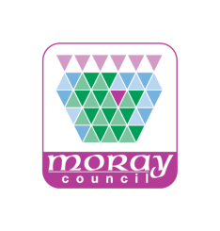

Volunteer Check List

Name

Action  Have you received the following? Sent/Given | Date | Comments
Initial Contact
Initial Enquiry from Volunteer
Initial Meeting/Phone Call with DofE Office
DofE Guiding Principles and Award Information
Volunteering Roles and Availability
Enrolment Form/Consent Forms to Volunteer
Forms returned to DofE Office
Administration
Information
Information
Reference Checks
ID Check by DofE Office
PVG Check
Information
Website information DofE.org & DofEMoray
Registration and Initial Log-in for eDofE
Sign up for DofE Magazine
Access to Leaders Handbook/ Expedition Guide
Establish Training Requirements
Introduction to training opportunities – Child Protection Training, Diversity, Challenging Behaviour, Food Hygiene, etc

Training
DofE e-induction (all volunteers)
Introduction to DofE course (within 6 months)
eDofE training
First Aid Qualification
Expedition Hard Skills
Mode of travel specific: e.g. Lowhills, DES, MTB Leader, etc
Expedition Supervisors Course
Supervised Lead for New Supervisors
Expedition Assessor Accreditation Scheme pre course e-learning
Expedition Assessor Accreditation Scheme Course
Supervised Assessment
Other Training:
Other Training:
Operating Authority Information
Access to Operations Manual and Excursions Policy
Local DofE structure and contacts
Expedition kit resources
MDEAC purpose and meeting information
Funding opportunities
TSI Moray
Other:

