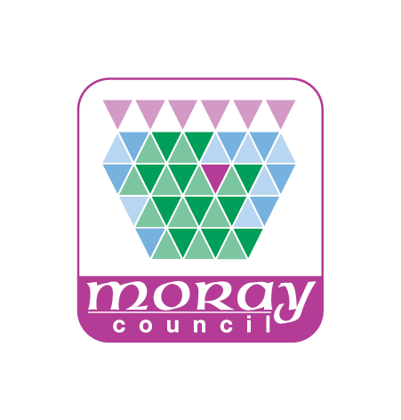

DofE
Operations Manual

for Centres and Volunteers
Operating under the
License of Moray Council

Attachments and Forms

2018 EDITION

List of Attachments

Moray DofE Management and Support Structure

Sample Partnership Agreement

MLAC Constitution

Parental Guidance/Consent Arrangements

Centre Check List

New Volunteer Procedure

Volunteer Enrolment Form

Volunteer Expenses Form

Volunteers Expenses Process

Participant Enrolment Form

Photographic Consent Form (Participants)

DofE Manager’s Leaflet for Parents

Bulk Buy Process

Expedition Fees Letter

Use and Limits of Expedition Qualifications

Supported Lead for Supervisors Form

Expedition Notification Letter

Parental Consent Form
- MLAC Funding Application Form

Example Route Card

Expedition Kit List

Base Contact Form

Supervisor’s Pack Contents List

Supervision Plan Form

Emergency Response Check List

Expedition Safety Card

Moray Council Incident Form

Note: DofE templates for Route Cards, Kit Lists, etc and other “Leaders” resources can be found at: https://www.dofe.org/leaders

You can also ask the DofE Moray Office at DofEMoray@moray.gov.uk for copies of any of the templates and forms in this document.

