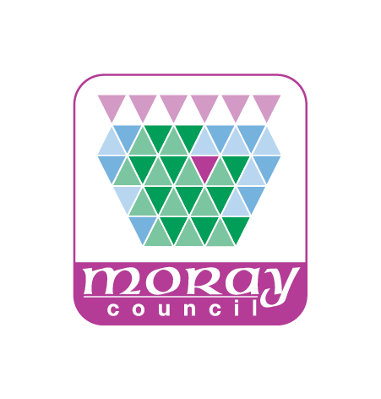
HEADTEACHER APPROVAL – DEPARTMENTAL PROGRAMME FOR SESSION 2018/19

PERMISSION TO SEND PUPILS ON UNACCOMPANIED CURRICULAR ACTIVITIES

Department

 | Year | Level | No of pupils | Brief description of activity
1
2
3
4
5
6

I certify that the above activities are likely to take place during the academic session specified above; that the activities are routine; that organising teachers will brief pupils appropriately; and that out-of-school information cards will be issued in accordance with procedures.

FOR OFFICE USE

I am satisfied that all reasonable safety measures have been taken in accordance with The Moray Council, Educational Services procedures and give approval for the above programme.

Signed
Date

