Agenda Template

A standard format for your Community Council agenda may be:

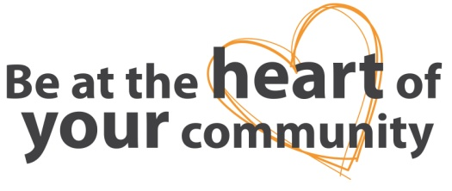
[Name of] Community Council Agenda
Date / Time / venue
Chair: |  | [name of]
Agenda
Police Update
It is good practice to allow the Police to speak at the outset of the meeting.
 | Guest Presentation
Minutes of Last Meeting
Attach to agenda.
 | Matters Arising
 | Correspondence
 | Treasurers Report
Community Feedback
This is where Community Councillors and Elected Members share matters received either informally or formally by residents or to give any visiting public the floor.
 | Reports
 | a) Local Councillor(s)
 | b) Community Council Sub Group(s)
 | c) A N Other(s)
 | Planning Issues
The Joint Community Council of Moray
Use this opportunity to hear updates from your JCC representative and agree any matters to be fed to the next JCC.
 | AOCB
 | Date, Time and Venue of Next Meeting

