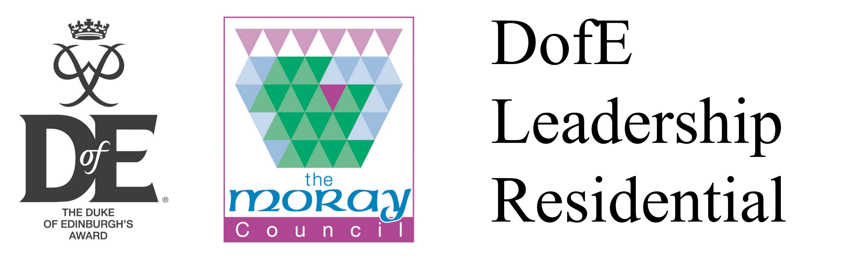

Participant booking form
Welcome to the 5 day DofE Leadership Residential running from;
Monday 25th July to Friday 29th July 2016: Findhorn village centre and hostel.
This residential will be a mixture of fun games, training sessions, activities and a wild camp. The aim is to train you up as accredited DofE leaders so you can start leading/ co-leading your own DofE bronze/silver group in your centre over the next year.
This residential could be used to complete your ‘Residential and volunteering sections’ of your Gold DofE award and is also accredited at SCQF level 5.
If you would like to book a space, please complete this booking form and send the form and booking fee (£70 made payable to ‘The Moray Council) to;
‘DofE Moray, Lossiemouth Community Centre, Coulardbank Rd, Lossiemouth, IV31 6JW. Thank you.’
Please also fill in and return the medical and parental consent form (enclosed), thank you.
Name
Date of Birth
Full address
Email
Contact telephone number
I confirm I would like to book onto the DofE Leadership Residential and I enclose payment of £70.00 made payable to ‘The Moray Council’ and the medical and consent form.
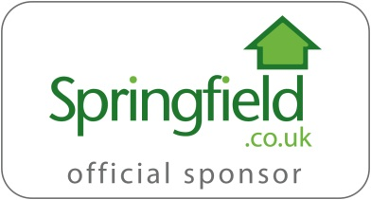
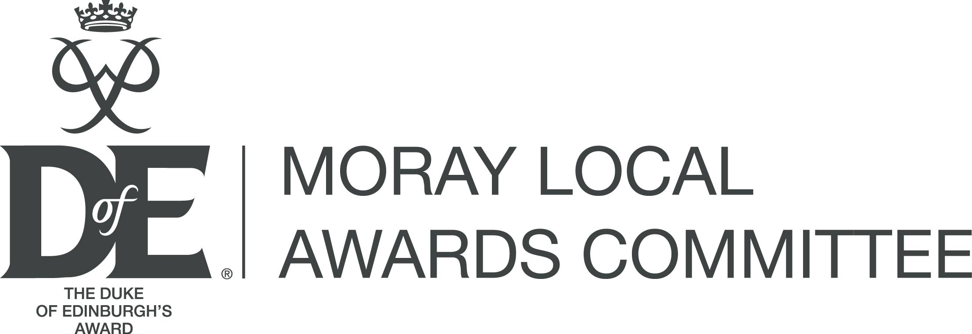
Signature: Date:

